Rc-artifacts for identification

|  |
| --- |
| [2 Piece Lot Genuine Aztec Copper Money Trade Axe Hoe](http://www.ebay.com/itm/330870184638?_trksid=p2057872.m2749.l2649&ssPageName=STRK%3AMEBIDX%3AIT)  ( 330870184638 )  Delivered on Thu, Dec 24  Tracking number: [**Tracking number**9405511899223188127791](javascript:;) |

**Due to recent political developments, these are no longer directly available. In real words, Mexico has restricted treasure hunters for ravaging the ancient treasures. Once my small existing supply supply is gone, that is it.**

 Here are some lots of TWO genuine antique Aztec copper trading hoes. Each unique piece is about 6" long and about 1.75" wide.   
**As we are selling a few different 2 piece lots, picture is an example of quality to expect.**

These are not China replicas, they are guaranteed authentic 13th century Aztec trading hoes and are very delicate.

The Aztecs were a barbarian tribe who came into the Valley of Mexico during the 13th Century. Their

language, Uto-Aztecan was once widely spoken from Washington State all the way down to Nicaragua. Hoe

(because of the shape) money was extensively used by all classes of Aztec society.

The axe money was fashioned entirely by working (hammering). In shaping the object, the original metal

blank was hammered and annealed many times to thin the metal, to spread the broad blade, and to form the

raised flange that runs along the edges of the shank. The metal was pounded severely in the final stage of

manufacture and was left in this forged condition, presumably to harden it.

After the object was shaped, a series of grooves was made on one surface, both in the shank and in the blade.

The photomicrographs reveal that these grooves were not cut into the metal. Rather, they were formed by a

hard tool that was pressed into and dragged along the surface of the object. This tool compressed the metal

immediately beneath it, forming the groove. The compressed, highly worked and deformed metal is

characterized by elongated grains full of strain lines produced by the force exerted by the tool.

item sold by [eluru_03](http://www.ebay.com/usr/eluru_03?_trksid=p2057872.m2749.l2754)

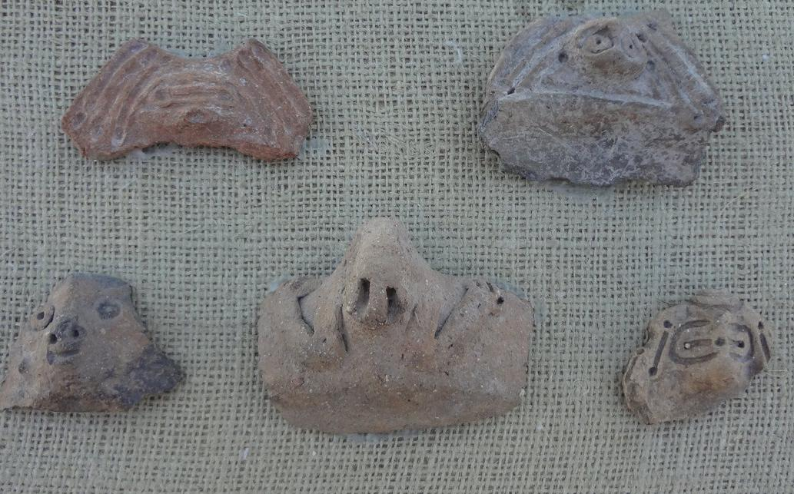 Taino heads panel , Ca. 900-1200 A.D.

|  |  |
| --- | --- |
| ORDER DATEDec 19, 2015 | ORDER TOTAL  US $99.00  + US $5.00  shipping  **Order 2 Piece Lot Genuine Aztec Copper Money Trade Axe Hoe** [Leave feedback - ORDER DATE Dec 19, 2015](http://feedback.ebay.com/ws/eBayISAPI.dll?LeaveFeedbackShow&useridto=*coppercarr*&transactID=1223409229014&item=330870184638&_trksid=p2057872.m2749.l2665)[View order details](http://payments.ebay.com/ws/eBayISAPI.dll?ViewPaymentStatus&transId=1223409229014&itemid=330870184638&_trksid=p2057872.m2749.l2673) - ORDER DATE Dec 19, 2015  [More actions - ORDER DATE Dec 19, 2015](http://www.ebay.com/myb/PurchaseHistory) |

1 item sold by [*coppercarr*](http://www.ebay.com/usr/*coppercarr*?_trksid=p2057872.m2749.l2754)

|  |  |  |  |  |
| --- | --- | --- | --- | --- |
|  | [Large Nayarit Woman Shaft Tomb Pre-Columbian Ancient Artifact Colima Aztec Mayan](http://www.ebay.com/itm/121846040301?_trksid=p2057872.m2749.l2649&ssPageName=STRK%3AMEBIDX%3AIT)  ( 121846040301 )  Delivered on Thu, Dec 31  Tracking number: [**Tracking number**9410809699938080889174](javascript:;)  [Add note](javascript:;) | | | ITEM PRICE:  US $177.50 |
| ORDER DATEDec 27, 2015 | | ORDER TOTAL  US $399.00  Free shipping  **Order LARGE Pre Columbian NAYARIT Pottery Painted Female Figure Solid and Heavy CHOICE** [Leave feedback - ORDER DATE Dec 27, 2015](http://feedback.ebay.com/ws/eBayISAPI.dll?LeaveFeedbackShow&useridto=zeus_gallery&transactID=0&item=301830834608&_trksid=p2057872.m2749.l2665)[View order details](http://payments.ebay.com/ws/eBayISAPI.dll?ViewPaymentStatus&transId=0&itemid=301830834608&_trksid=p2057872.m2749.l2673) - ORDER DATE Dec 27, 2015  [More actions - ORDER DATE Dec 27, 2015](http://www.ebay.com/myb/PurchaseHistory) |  | |

1 item sold by [zeus_gallery](http://www.ebay.com/usr/zeus_gallery?_trksid=p2057872.m2749.l2754)

|  |  |  |  |  |
| --- | --- | --- | --- | --- |
| [LARGE Pre Columbian NAYARIT Pottery Painted Female Figure Solid and Heavy CHOICE](http://www.ebay.com/itm/301830834608?_trksid=p2057872.m2749.l2649&ssPageName=STRK%3AMEBIDX%3AIT)  ( 301830834608 )  Delivered on Thu, Dec 31  Tracking number: [**Tracking number**9405509699937202451562](javascript:;) | | | | |
|  | [Colima Large Incense Lid Shaft Tomb Pre-Columbian Archaic Ancient Artifact Mayan](http://www.ebay.com/itm/191762068598?_trksid=p2057872.m2749.l2649&ssPageName=STRK%3AMEBIDX%3AIT)  ( 191762068598 )  Delivered on Thu, Dec 31  Tracking number: [**Tracking number**9410809699938075855252](javascript:;)  [Add note](javascript:;) | ITEM PRICE:  US $34.01 | **Item Colima Large Incense Lid Shaft Tomb Pre-Columbian Archaic Ancient Artifact Mayan Orders 191762068598-0-0**[Leave feedback](http://feedback.ebay.com/ws/eBayISAPI.dll?LeaveFeedbackShow&useridto=bobski117&transactID=0&item=191762068598&_trksid=p2057872.m2749.l2665)[Return this item](http://postorder.ebay.com/Return/ReturnViewSelectedItem?transactionId=0&itemId=191762068598&_trksid=p2057872.m2749.l3185)  [More actions](http://www.ebay.com/myb/PurchaseHistory) |  |

|  |  |
| --- | --- |
| ORDER DATEDec 24, 2015 | ORDER TOTAL  US $400.00  + US $17.90  shipping  **Order Moche IV Blow Bottle 400-600AD Weapon Bundle And Wave + Step Motif** [Leave feedback - ORDER DATE Dec 24, 2015](http://feedback.ebay.com/ws/eBayISAPI.dll?LeaveFeedbackShow&useridto=ancientgas&transactID=0&item=221952944734&_trksid=p2057872.m2749.l2665)[View order details](http://payments.ebay.com/ws/eBayISAPI.dll?ViewPaymentStatus&transId=0&itemid=221952944734&_trksid=p2057872.m2749.l2673) - ORDER DATE Dec 24, 2015  [More actions - ORDER DATE Dec 24, 2015](http://www.ebay.com/myb/PurchaseHistory) |

1 item sold by [ancientgas](http://www.ebay.com/usr/ancientgas?_trksid=p2057872.m2749.l2754)

|  |  |  |  |
| --- | --- | --- | --- |
| [Moche IV Blow Bottle 400-600AD Weapon Bundle And Wave + Step Motif](http://www.ebay.com/itm/221952944734?_trksid=p2057872.m2749.l2649&ssPageName=STRK%3AMEBIDX%3AIT)  ( 221952944734 )  Estimated delivery Wed, Dec 30 - Mon, Jan 04  Tracking number: [**Tracking number**9500111060105360398548](javascript:;) | | | |
|  | ORDER DATEDec 24, 2015 | ORDER TOTAL  US $199.00  + US $40.00  shipping  **Order Taino Ceremonial Stone Ring Pre Columbian** [Leave feedback - ORDER DATE Dec 24, 2015](http://feedback.ebay.com/ws/eBayISAPI.dll?LeaveFeedbackShow&useridto=artetaino&transactID=0&item=151923653796&_trksid=p2057872.m2749.l2665)[View order details](http://payments.ebay.com/ws/eBayISAPI.dll?ViewPaymentStatus&transId=0&itemid=151923653796&_trksid=p2057872.m2749.l2673) - ORDER DATE Dec 24, 2015  [More actions - ORDER DATE Dec 24, 2015](http://www.ebay.com/myb/PurchaseHistory) |  |

1 item sold by [artetaino](http://www.ebay.com/usr/artetaino?_trksid=p2057872.m2749.l2754)

|  |  |  |  |
| --- | --- | --- | --- |
| [Taino Ceremonial Stone Ring Pre Columbian](http://www.ebay.com/itm/151923653796?_trksid=p2057872.m2749.l2649&ssPageName=STRK%3AMEBIDX%3AIT)  ( 151923653796 )  Estimated delivery Wed, Dec 30 - Mon, Jan 04  Tracking number: [**Tracking number**808742908357](javascript:;) | | | |
|  | ORDER DATEDec 22, 2015 | ORDER TOTAL  US $43.00  + US $20.00  shipping  **Order Ancient Egyptian blue Ushabti antiques,Ancient Egyptian Blue Ushabti antiques** [View order details - ORDER DATE Dec 22, 2015](http://payments.ebay.com/ws/eBayISAPI.dll?ViewPaymentStatus&transId=0&itemid=161923093700&_trksid=p2057872.m2749.l2673)[Contact seller](http://contact.ebay.com/ws/eBayISAPI.dll?ShowSellerFAQ&requested=amafamily12&iid=161923093700&redirect=0&_trksid=p2057872.m2749.l2652) - ORDER DATE Dec 22, 2015  [More actions - ORDER DATE Dec 22, 2015](http://www.ebay.com/myb/PurchaseHistory) |  |

2 items sold by [amafamily12](http://www.ebay.com/usr/amafamily12?_trksid=p2057872.m2749.l2754)

|  |  |  |
| --- | --- | --- |
| [Ancient Egyptian blue Ushabti antiques](http://www.ebay.com/itm/161923093700?_trksid=p2057872.m2749.l2649&ssPageName=STRK%3AMEBIDX%3AIT)  ( 161923093700 )  Estimated delivery Thu, Jan 14 - Thu, Jan 21  [Add note](javascript:;) | ITEM PRICE:  US $20.00 | **Item Ancient Egyptian blue Ushabti antiques Orders 161923093700-0-0**[Leave feedback](http://feedback.ebay.com/ws/eBayISAPI.dll?LeaveFeedbackShow&useridto=amafamily12&transactID=0&item=161923093700&_trksid=p2057872.m2749.l2665)[Return this item](http://postorder.ebay.com/Return/ReturnViewSelectedItem?transactionId=0&itemId=161923093700&_trksid=p2057872.m2749.l3185)  [More actions](http://www.ebay.com/myb/PurchaseHistory) |

|  |  |  |
| --- | --- | --- |
| [Ancient Egyptian Blue Ushabti antiques](http://www.ebay.com/itm/161923098286?_trksid=p2057872.m2749.l2649&ssPageName=STRK%3AMEBIDX%3AIT)  ( 161923098286 )  Estimated delivery Thu, Jan 14 - Thu, Jan 21  [Add note](javascript:;) | ITEM PRICE:  US $23.00 | **Item Ancient Egyptian Blue Ushabti antiques Orders 161923098286-0-0**[Leave feedback](http://feedback.ebay.com/ws/eBayISAPI.dll?LeaveFeedbackShow&useridto=amafamily12&transactID=0&item=161923098286&_trksid=p2057872.m2749.l2665)[Return this item](http://postorder.ebay.com/Return/ReturnViewSelectedItem?transactionId=0&itemId=161923098286&_trksid=p2057872.m2749.l3185)  [More actions](http://www.ebay.com/myb/PurchaseHistory) |

|  |  |
| --- | --- |
| ORDER DATEDec 22, 2015 | ORDER TOTAL  US $110.50  + US $35.00  shipping  **Order Ancient Egyptian green Ushabti,Ancient Egyptian 5 Amulets antiques,Ancient Egyptian 5 Amulets antiques,Ancient Egyptian 6 Amulets antiques** [View order details - ORDER DATE Dec 22, 2015](http://payments.ebay.com/ws/eBayISAPI.dll?ViewPaymentStatus&transId=0&itemid=161923106584&_trksid=p2057872.m2749.l2673)[Contact seller](http://contact.ebay.com/ws/eBayISAPI.dll?ShowSellerFAQ&requested=amafamily12&iid=161923106584&redirect=0&_trksid=p2057872.m2749.l2652) - ORDER DATE Dec 22, 2015  [More actions - ORDER DATE Dec 22, 2015](http://www.ebay.com/myb/PurchaseHistory) |

4 items sold by [amafamily12](http://www.ebay.com/usr/amafamily12?_trksid=p2057872.m2749.l2754)

|  |  |  |
| --- | --- | --- |
| [Ancient Egyptian green Ushabti](http://www.ebay.com/itm/161923106584?_trksid=p2057872.m2749.l2649&ssPageName=STRK%3AMEBIDX%3AIT)  ( 161923106584 )  Estimated delivery Thu, Jan 14 - Thu, Jan 21  [Add note](javascript:;) | ITEM PRICE:  US $18.50 | **Item Ancient Egyptian green Ushabti Orders 161923106584-0-0**[Leave feedback](http://feedback.ebay.com/ws/eBayISAPI.dll?LeaveFeedbackShow&useridto=amafamily12&transactID=0&item=161923106584&_trksid=p2057872.m2749.l2665)[Return this item](http://postorder.ebay.com/Return/ReturnViewSelectedItem?transactionId=0&itemId=161923106584&_trksid=p2057872.m2749.l3185)  [More actions](http://www.ebay.com/myb/PurchaseHistory) |

|  |  |  |
| --- | --- | --- |
| [Ancient Egyptian 5 Amulets antiques](http://www.ebay.com/itm/161923109147?_trksid=p2057872.m2749.l2649&ssPageName=STRK%3AMEBIDX%3AIT)  ( 161923109147 )  Estimated delivery Thu, Jan 14 - Thu, Jan 21  [Add note](javascript:;) | ITEM PRICE:  US $37.00 | **Item Ancient Egyptian 5 Amulets antiques Orders 161923109147-0-0**[Leave feedback](http://feedback.ebay.com/ws/eBayISAPI.dll?LeaveFeedbackShow&useridto=amafamily12&transactID=0&item=161923109147&_trksid=p2057872.m2749.l2665)[Return this item](http://postorder.ebay.com/Return/ReturnViewSelectedItem?transactionId=0&itemId=161923109147&_trksid=p2057872.m2749.l3185)  [More actions](http://www.ebay.com/myb/PurchaseHistory) |

|  |  |  |
| --- | --- | --- |
| [Ancient Egyptian 5 Amulets antiques](http://www.ebay.com/itm/161923110016?_trksid=p2057872.m2749.l2649&ssPageName=STRK%3AMEBIDX%3AIT)  ( 161923110016 )  Estimated delivery Thu, Jan 14 - Thu, Jan 21  [Add note](javascript:;) | ITEM PRICE:  US $25.00 | **Item Ancient Egyptian 5 Amulets antiques Orders 161923110016-0-0**[Leave feedback](http://feedback.ebay.com/ws/eBayISAPI.dll?LeaveFeedbackShow&useridto=amafamily12&transactID=0&item=161923110016&_trksid=p2057872.m2749.l2665)[Return this item](http://postorder.ebay.com/Return/ReturnViewSelectedItem?transactionId=0&itemId=161923110016&_trksid=p2057872.m2749.l3185)  [More actions](http://www.ebay.com/myb/PurchaseHistory) |

|  |  |  |
| --- | --- | --- |
| [Ancient Egyptian 6 Amulets antiques](http://www.ebay.com/itm/161923111059?_trksid=p2057872.m2749.l2649&ssPageName=STRK%3AMEBIDX%3AIT)  ( 161923111059 )  Estimated delivery Thu, Jan 14 - Thu, Jan 21  [Add note](javascript:;) | ITEM PRICE:  US $30.00 | **Item Ancient Egyptian 6 Amulets antiques Orders 161923111059-0-0**[Leave feedback](http://feedback.ebay.com/ws/eBayISAPI.dll?LeaveFeedbackShow&useridto=amafamily12&transactID=0&item=161923111059&_trksid=p2057872.m2749.l2665)[Return this item](http://postorder.ebay.com/Return/ReturnViewSelectedItem?transactionId=0&itemId=161923111059&_trksid=p2057872.m2749.l3185)  [More actions](http://www.ebay.com/myb/PurchaseHistory) |

|  |  |
| --- | --- |
| ORDER DATEDec 22, 2015 | ORDER TOTAL  US $45.00  + US $20.00  shipping  **Order Ancient Egyptian Ushabti antiques,Ancient Egyptian Blue Ushabti antiques** [View order details - ORDER DATE Dec 22, 2015](http://payments.ebay.com/ws/eBayISAPI.dll?ViewPaymentStatus&transId=0&itemid=161923073895&_trksid=p2057872.m2749.l2673)[Contact seller](http://contact.ebay.com/ws/eBayISAPI.dll?ShowSellerFAQ&requested=amafamily12&iid=161923073895&redirect=0&_trksid=p2057872.m2749.l2652) - ORDER DATE Dec 22, 2015  [More actions - ORDER DATE Dec 22, 2015](http://www.ebay.com/myb/PurchaseHistory) |

2 items sold by [amafamily12](http://www.ebay.com/usr/amafamily12?_trksid=p2057872.m2749.l2754)

|  |  |  |
| --- | --- | --- |
| [Ancient Egyptian Ushabti antiques](http://www.ebay.com/itm/161923073895?_trksid=p2057872.m2749.l2649&ssPageName=STRK%3AMEBIDX%3AIT)  ( 161923073895 )  Estimated delivery Thu, Jan 14 - Thu, Jan 21  [Add note](javascript:;) | ITEM PRICE:  US $25.00 | **Item Ancient Egyptian Ushabti antiques Orders 161923073895-0-0**[Leave feedback](http://feedback.ebay.com/ws/eBayISAPI.dll?LeaveFeedbackShow&useridto=amafamily12&transactID=0&item=161923073895&_trksid=p2057872.m2749.l2665)[Return this item](http://postorder.ebay.com/Return/ReturnViewSelectedItem?transactionId=0&itemId=161923073895&_trksid=p2057872.m2749.l3185)  [More actions](http://www.ebay.com/myb/PurchaseHistory) |

|  |  |  |
| --- | --- | --- |
| [Ancient Egyptian Blue Ushabti antiques](http://www.ebay.com/itm/161923077618?_trksid=p2057872.m2749.l2649&ssPageName=STRK%3AMEBIDX%3AIT)  ( 161923077618 )  Estimated delivery Thu, Jan 14 - Thu, Jan 21  [Add note](javascript:;) | ITEM PRICE:  US $20.00 | **Item Ancient Egyptian Blue Ushabti antiques Orders 161923077618-0-0**[Leave feedback](http://feedback.ebay.com/ws/eBayISAPI.dll?LeaveFeedbackShow&useridto=amafamily12&transactID=0&item=161923077618&_trksid=p2057872.m2749.l2665)[Return this item](http://postorder.ebay.com/Return/ReturnViewSelectedItem?transactionId=0&itemId=161923077618&_trksid=p2057872.m2749.l3185)  [More actions](http://www.ebay.com/myb/PurchaseHistory) |

|  |  |
| --- | --- |
| ORDER DATEDec 22, 2015 | ORDER TOTAL  US $48.53  + US $15.00  shipping  **Order Ancient Egyptian Ushabti antiques of God Bes,Ancient Egyptian Blue Ushabti antiques** [View order details - ORDER DATE Dec 22, 2015](http://payments.ebay.com/ws/eBayISAPI.dll?ViewPaymentStatus&transId=0&itemid=161922800704&_trksid=p2057872.m2749.l2673)[Contact seller](http://contact.ebay.com/ws/eBayISAPI.dll?ShowSellerFAQ&requested=amafamily12&iid=161922800704&redirect=0&_trksid=p2057872.m2749.l2652) - ORDER DATE Dec 22, 2015  [More actions - ORDER DATE Dec 22, 2015](http://www.ebay.com/myb/PurchaseHistory) |

2 items sold by [amafamily12](http://www.ebay.com/usr/amafamily12?_trksid=p2057872.m2749.l2754)

|  |  |  |
| --- | --- | --- |
| [Ancient Egyptian Ushabti antiques of God Bes](http://www.ebay.com/itm/161922800704?_trksid=p2057872.m2749.l2649&ssPageName=STRK%3AMEBIDX%3AIT)  ( 161922800704 )  Estimated delivery Thu, Jan 14 - Thu, Jan 21  [Add note](javascript:;) | ITEM PRICE:  US $15.00 | **Item Ancient Egyptian Ushabti antiques of God Bes Orders 161922800704-0-0**[Leave feedback](http://feedback.ebay.com/ws/eBayISAPI.dll?LeaveFeedbackShow&useridto=amafamily12&transactID=0&item=161922800704&_trksid=p2057872.m2749.l2665)[Return this item](http://postorder.ebay.com/Return/ReturnViewSelectedItem?transactionId=0&itemId=161922800704&_trksid=p2057872.m2749.l3185)  [More actions](http://www.ebay.com/myb/PurchaseHistory) |

|  |  |  |
| --- | --- | --- |
| [Ancient Egyptian Blue Ushabti antiques](http://www.ebay.com/itm/161923066755?_trksid=p2057872.m2749.l2649&ssPageName=STRK%3AMEBIDX%3AIT)  ( 161923066755 )  Estimated delivery Thu, Jan 14 - Thu, Jan 21  [Add note](javascript:;) | ITEM PRICE:  US $33.53 | **Item Ancient Egyptian Blue Ushabti antiques Orders 161923066755-0-0**[Leave feedback](http://feedback.ebay.com/ws/eBayISAPI.dll?LeaveFeedbackShow&useridto=amafamily12&transactID=0&item=161923066755&_trksid=p2057872.m2749.l2665)[Return this item](http://postorder.ebay.com/Return/ReturnViewSelectedItem?transactionId=0&itemId=161923066755&_trksid=p2057872.m2749.l3185)  [More actions](http://www.ebay.com/myb/PurchaseHistory) |

|  |  |
| --- | --- |
| ORDER DATEDec 21, 2015 | ORDER TOTAL  US $61.00  + US $25.00  shipping  **Order Ancient Egyptian Blue Ushabti antiques of God Anubis,Ancient Egyptian Yellow Ushabti antiques** [View order details - ORDER DATE Dec 21, 2015](http://payments.ebay.com/ws/eBayISAPI.dll?ViewPaymentStatus&transId=0&itemid=221972542593&_trksid=p2057872.m2749.l2673)[Contact seller](http://contact.ebay.com/ws/eBayISAPI.dll?ShowSellerFAQ&requested=slisli4&iid=221972542593&redirect=0&_trksid=p2057872.m2749.l2652) - ORDER DATE Dec 21, 2015  [More actions - ORDER DATE Dec 21, 2015](http://www.ebay.com/myb/PurchaseHistory) |

2 items sold by [slisli4](http://www.ebay.com/usr/slisli4?_trksid=p2057872.m2749.l2754)

|  |  |  |
| --- | --- | --- |
| [Ancient Egyptian Blue Ushabti antiques of God Anubis](http://www.ebay.com/itm/221972542593?_trksid=p2057872.m2749.l2649&ssPageName=STRK%3AMEBIDX%3AIT)  ( 221972542593 )  Estimated delivery Thu, Jan 14 - Thu, Jan 21  [Add note](javascript:;) | ITEM PRICE:  US $41.00 | **Item Ancient Egyptian Blue Ushabti antiques of God Anubis Orders 221972542593-0-0**[Leave feedback](http://feedback.ebay.com/ws/eBayISAPI.dll?LeaveFeedbackShow&useridto=slisli4&transactID=0&item=221972542593&_trksid=p2057872.m2749.l2665)[Return this item](http://postorder.ebay.com/Return/ReturnViewSelectedItem?transactionId=0&itemId=221972542593&_trksid=p2057872.m2749.l3185)  [More actions](http://www.ebay.com/myb/PurchaseHistory) |

|  |  |  |
| --- | --- | --- |
| [Ancient Egyptian Yellow Ushabti antiques](http://www.ebay.com/itm/221972558965?_trksid=p2057872.m2749.l2649&ssPageName=STRK%3AMEBIDX%3AIT)  ( 221972558965 )  Estimated delivery Thu, Jan 14 - Thu, Jan 21  [Add note](javascript:;) | ITEM PRICE:  US $20.00 | **Item Ancient Egyptian Yellow Ushabti antiques Orders 221972558965-0-0**[Leave feedback](http://feedback.ebay.com/ws/eBayISAPI.dll?LeaveFeedbackShow&useridto=slisli4&transactID=0&item=221972558965&_trksid=p2057872.m2749.l2665)[Return this item](http://postorder.ebay.com/Return/ReturnViewSelectedItem?transactionId=0&itemId=221972558965&_trksid=p2057872.m2749.l3185)  [More actions](http://www.ebay.com/myb/PurchaseHistory) |

|  |  |
| --- | --- |
| ORDER DATEDec 22, 2015 | ORDER TOTAL  US $212.50  + US $40.00  shipping  **Order Taino Pre Columbian Tripointer** [Leave feedback - ORDER DATE Dec 22, 2015](http://feedback.ebay.com/ws/eBayISAPI.dll?LeaveFeedbackShow&useridto=miuarez&transactID=0&item=272081870660&_trksid=p2057872.m2749.l2665)[View order details](http://payments.ebay.com/ws/eBayISAPI.dll?ViewPaymentStatus&transId=0&itemid=272081870660&_trksid=p2057872.m2749.l2673) - ORDER DATE Dec 22, 2015  [More actions - ORDER DATE Dec 22, 2015](http://www.ebay.com/myb/PurchaseHistory) |

1 item sold by [miuarez](http://www.ebay.com/usr/miuarez?_trksid=p2057872.m2749.l2754)

|  |  |  |
| --- | --- | --- |
| [Taino Pre Columbian Tripointer](http://www.ebay.com/itm/272081870660?_trksid=p2057872.m2749.l2649&ssPageName=STRK%3AMEBIDX%3AIT)  ( 272081870660 )  Delivered on Tue, Dec 29  Tracking number: [**Tracking number**1ZV8200Y6692015616](javascript:;)  [Add note](javascript:;) | ITEM PRICE:  US $212.50 |  |

|  |  |
| --- | --- |
| ORDER DATEDec 21, 2015 | ORDER TOTAL  US $184.50  + US $18.00  shipping  **Order Costa Rica Ex-Gallery Vessel Pre-Columbian Archaic Ancient Artifact Nicoya Mayan** [Leave feedback - ORDER DATE Dec 21, 2015](http://feedback.ebay.com/ws/eBayISAPI.dll?LeaveFeedbackShow&useridto=bobski117&transactID=0&item=191760304787&_trksid=p2057872.m2749.l2665)[View order details](http://payments.ebay.com/ws/eBayISAPI.dll?ViewPaymentStatus&transId=0&itemid=191760304787&_trksid=p2057872.m2749.l2673) - ORDER DATE Dec 21, 2015  [More actions - ORDER DATE Dec 21, 2015](http://www.ebay.com/myb/PurchaseHistory) |

1 item sold by [bobski117](http://www.ebay.com/usr/bobski117?_trksid=p2057872.m2749.l2754)

|  |
| --- |
| [Costa Rica Ex-Gallery Vessel Pre-Columbian Archaic Ancient Artifact Nicoya Mayan](http://www.ebay.com/itm/191760304787?_trksid=p2057872.m2749.l2649&ssPageName=STRK%3AMEBIDX%3AIT)  ( 191760304787 )  Delivered on Sat, Dec 26  Tracking number: [**Tracking number**9410809699937189284408](javascript:;) |

This rare ceremonial belt was crafted by the Moche Culture of Coastal Peru. It has the image of a Moche Ruler or Warrior in the middle. There are two owls on either side of the face. There are dangle ear ring elements going around it and imprinted designs. This is a very rare artifact that is rarely seen. This is truly a museum quality artifact. It has heavy oxidation at displays very, very nicely. It gets a lot of attention. It is 23 inches long and over 4 inches wide. This incredible artifact dates to 200-800AD and could be a centerpiece for any collection.

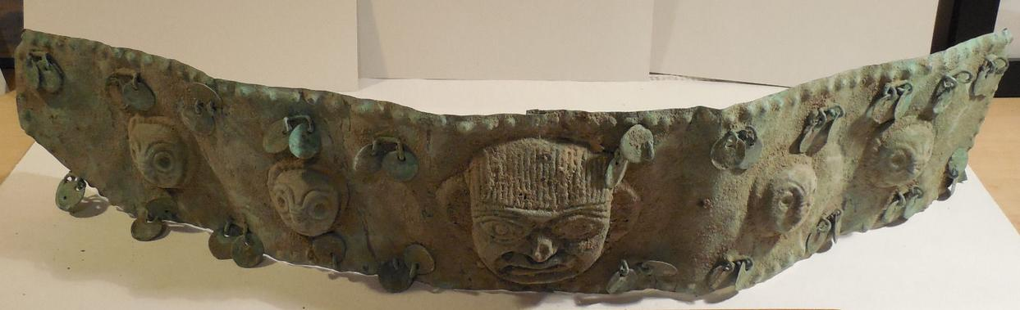

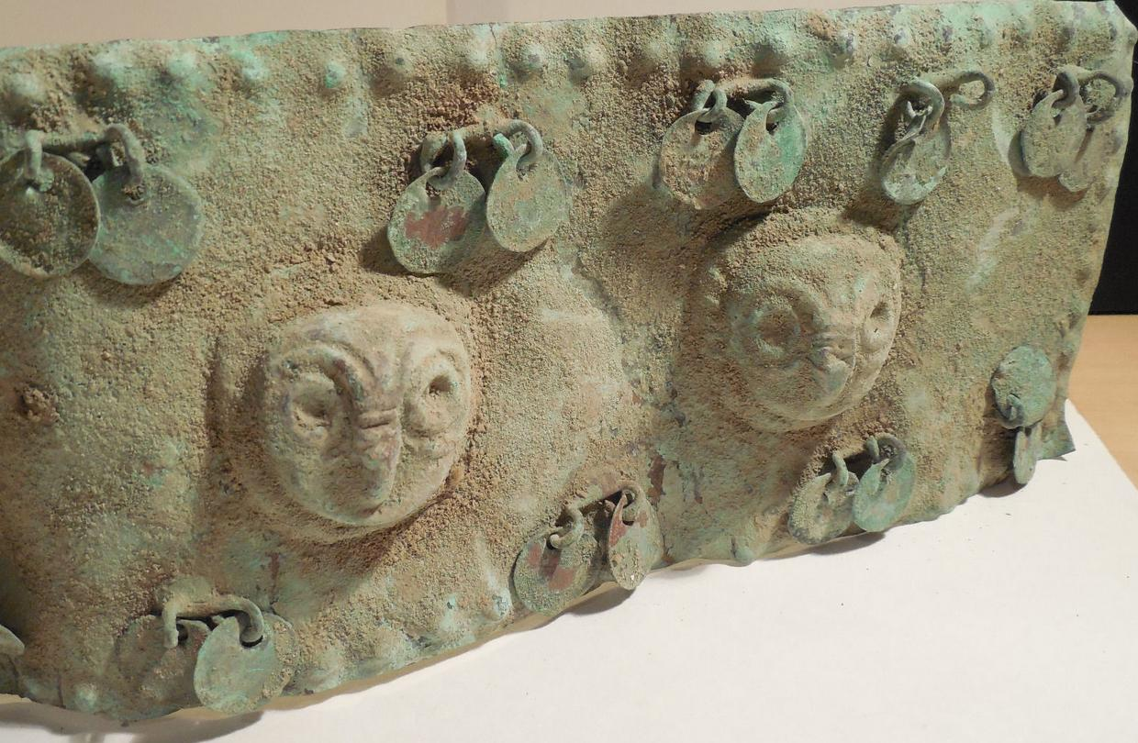

|  |  |
| --- | --- |
| ORDER DATEDec 21, 2015 | ORDER TOTAL  US $65.00  + US $5.00  shipping  **Order Guaranteed 100 % Authentic Pre-Columbian Peru Bronze Tumi Ring** [Leave feedback - ORDER DATE Dec 21, 2015](http://feedback.ebay.com/ws/eBayISAPI.dll?LeaveFeedbackShow&useridto=cornfeddogger&transactID=0&item=121840433680&_trksid=p2057872.m2749.l2665)[View order details](http://payments.ebay.com/ws/eBayISAPI.dll?ViewPaymentStatus&transId=0&itemid=121840433680&_trksid=p2057872.m2749.l2673) - ORDER DATE Dec 21, 2015  [More actions - ORDER DATE Dec 21, 2015](http://www.ebay.com/myb/PurchaseHistory) |

1 item sold by [cornfeddogger](http://www.ebay.com/usr/cornfeddogger?_trksid=p2057872.m2749.l2754)

|  |
| --- |
| [Guaranteed 100 % Authentic Pre-Columbian Peru Bronze Tumi Ring](http://www.ebay.com/itm/121840433680?_trksid=p2057872.m2749.l2649&ssPageName=STRK%3AMEBIDX%3AIT)  ( 121840433680 ) |

|  |
| --- |
| [bone spoon,precolumbian.moche,mochica](http://www.ebay.com/itm/262189922720?_trksid=p2057872.m2749.l2649&ssPageName=STRK%3AMEBIDX%3AIT)  ( 262189922720 )  Estimated delivery Mon, Jan 04 - Mon, Jan 11 |

**spoon bone of a Moche elite character**

**takes encrustations, small restoration on the nose**

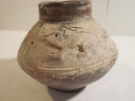

[Chimu Coati Vessel Pre-Colombian Archaic Aancient Artifact Moche Inca Mayan NR](http://www.ebay.com/itm/121833218610?_trksid=p2057872.m2749.l2649&ssPageName=STRK%3AMEBIDX%3AIT)

( 121833218610 )

|  |
| --- |
| ORDER TOTAL  US $237.06  + US $12.00  shipping |

Chimu Coati vessel for auction at no reserve. This ancient vessel has a dark brown slip and a cream colored band going around it with incised designs. It has the figure of a Coati on one side, and incised wave designs in the cream colored band going around it. This ancient artifact is intact other than some minor chips at the rim of the spout. It stands by itself, has great patina, and displays very nicely. This great ancient vessel dates to 900-1470AD and would be a great addition to any collection. The Chimu came to power after the Moche and were defeated by the Inca in 1470AD.

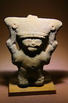

[pre-Columbian figure ceramic smiling face wTL test Mayan X-MAS Special Price WOW](http://www.ebay.com/itm/121833589153?_trksid=p2057872.m2749.l2649&ssPageName=STRK%3AMEBIDX%3AIT)

( 121833589153 )

You are bidding on a complete figures flute of Veracruz Maya with stand. The figure shows the typical and popular among collectors of smile. Other features are the god awe raised arms and huge headdress representing mythological beast. The head is in the mouth and big eyes are located close to the outer corners. The flute works very nice, the surface is drawn uniformly with time (old aged patina), is an authentic piece without senseless machining marks.

Come with stand!!

See the price inclusive the lab test, unbeatable!

**Culture: Veracruz, Maya, 900-1300AD Post Classic Period**

**Age: 800 years old, TL tested, new Test Document 2014 inclusive!**

Tall approx.: 6”

|  |  |
| --- | --- |
| Dec 12, 2015 | ORDER TOTAL  US $500.00  + US $65.00  shipping  **Order Rare Precolumbian Figure Bottle Peru Moche Traveler Vessel 3rd–5th century** [Leave feedback - ORDER DATE Dec 12, 2015](http://feedback.ebay.com/ws/eBayISAPI.dll?LeaveFeedbackShow&useridto=remymarcel&transactID=1261022103013&item=231775811732&_trksid=p2057872.m2749.l2665)[View order details](http://payments.ebay.com/ws/eBayISAPI.dll?ViewPaymentStatus&transId=1261022103013&itemid=231775811732&_trksid=p2057872.m2749.l2673) - ORDER DATE Dec 12, 2015  [More actions - ORDER DATE Dec 12, 2015](http://www.ebay.com/myb/PurchaseHistory) |

1 item sold by [remymarcel](http://www.ebay.com/usr/remymarcel?_trksid=p2057872.m2749.l2754)

|  |  |
| --- | --- |
| [Rare Precolumbian Figure Bottle Peru Moche Traveler Vessel 3rd–5th century](http://www.ebay.com/itm/231775811732?_trksid=p2057872.m2749.l2649&ssPageName=STRK%3AMEBIDX%3AIT)  ( 231775811732 )  Delivered on Thu, Dec 24  Tracking number: [**Tracking number**1z580w576740002462](javascript:;)  [Add note](javascript:;) | ITEM PRICE: |

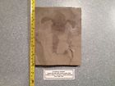

[Eurypterus remipes Fossil Upper Silurian - New York](http://www.ebay.com/itm/151913109924?_trksid=p2057872.m2749.l2649&ssPageName=STRK%3AMEBIDX%3AIT)

( 151913109924 )

|  |
| --- |
| US $435.00  + US $18.00  shipping  **Order pre-Columbian portrait head warrior wTL test AiApaec X-MAS Special Price WOW!!** [Leave feedback - ORDER DATE Dec 11, 2015](http://feedback.ebay.com/ws/eBayISAPI.dll?LeaveFeedbackShow&useridto=dsevveinl&transactID=0&item=121832892332&_trksid=p2057872.m2749.l2665)[View order details](http://payments.ebay.com/ws/eBayISAPI.dll?ViewPaymentStatus&transId=0&itemid=121832892332&_trksid=p2057872.m2749.l2673) - ORDER DATE Dec 11, 2015  [More actions - ORDER DATE Dec 11, 2015](http://www.ebay.com/myb/PurchaseHistory) |

1 item sold by [dsevveinl](http://www.ebay.com/usr/dsevveinl?_trksid=p2057872.m2749.l2754)

|  |  |  |  |
| --- | --- | --- | --- |
|  | | | |
|  | ORDER DATEDec 11, 2015 | ORDER TOTAL  US $78.98  + US $14.00  shipping  **Order Moche Owl Vessel Pre-Columbian Archaic Ancient Artifact Mochica Chimu Inca Mayan** [Leave feedback - ORDER DATE Dec 11, 2015](http://feedback.ebay.com/ws/eBayISAPI.dll?LeaveFeedbackShow&useridto=bobski117&transactID=0&item=121832508742&_trksid=p2057872.m2749.l2665)[View order details](http://payments.ebay.com/ws/eBayISAPI.dll?ViewPaymentStatus&transId=0&itemid=121832508742&_trksid=p2057872.m2749.l2673) - ORDER DATE Dec 11, 2015  [More actions - ORDER DATE Dec 11, 2015](http://www.ebay.com/myb/PurchaseHistory) |  |

1 item sold by [bobski117](http://www.ebay.com/usr/bobski117?_trksid=p2057872.m2749.l2754)

|  |  |  |  |
| --- | --- | --- | --- |
| [Moche Owl Vessel Pre-Columbian Archaic Ancient Artifact Mochica Chimu Inca Mayan](http://www.ebay.com/itm/121832508742?_trksid=p2057872.m2749.l2649&ssPageName=STRK%3AMEBIDX%3AIT)  ( 121832508742 )  Delivered on Tue, Dec 15  Tracking number: [**Tracking number**9410809699939516767509](javascript:;) | | | |
|  | Dec 11, 2015 | ORDER TOTAL  US $115.00  + US $10.50  shipping  **Order BIG 5.75" Perisphinctes 146mm SPIRAL RIBBED AMMONITE Jurassic FOSSIL 1lb 14oz** [Leave feedback - ORDER DATE Dec 11, 2015](http://feedback.ebay.com/ws/eBayISAPI.dll?LeaveFeedbackShow&useridto=thatswhat&transactID=1260892373013&item=231157204278&_trksid=p2057872.m2749.l2665)[View order details](http://payments.ebay.com/ws/eBayISAPI.dll?ViewPaymentStatus&transId=1260892373013&itemid=231157204278&_trksid=p2057872.m2749.l2673) - ORDER DATE Dec 11, 2015  [More actions - ORDER DATE Dec 11, 2015](http://www.ebay.com/myb/PurchaseHistory) |  |

1 item sold by [thatswhat](http://www.ebay.com/usr/thatswhat?_trksid=p2057872.m2749.l2754)

|  |  |
| --- | --- |
| [BIG 5.75" Perisphinctes 146mm SPIRAL RIBBED AMMONITE Jurassic FOSSIL 1lb 14oz](http://www.ebay.com/itm/231157204278?_trksid=p2057872.m2749.l2649&ssPageName=STRK%3AMEBIDX%3AIT)  ( 231157204278 )  Delivered on Sun, Dec 13  Tracking number: [**Tracking number**9405509699938031850649](javascript:;)  [Add note](javascript:;) | ITEM PRICE:  US $115.00 |

|  |  |  |
| --- | --- | --- |
| [Add note](javascript:;) | ITEM PRICE:  US $17.00 |  |

|  |  |
| --- | --- |
| ORDER DATEDec 11, 2015 | ORDER TOTAL  US $285.00  + US $25.00  shipping  **Order PERU PRECOLUMBIAN MOCHICA MOCHE VESSEL - 700 AD - VASE PRE COLOMBIEN MOCHICA** [Leave feedback - ORDER DATE Dec 11, 2015](http://feedback.ebay.com/ws/eBayISAPI.dll?LeaveFeedbackShow&useridto=ancient_artonline&transactID=1766730350015&item=252151646311&_trksid=p2057872.m2749.l2665)[View order details](http://payments.ebay.com/ws/eBayISAPI.dll?ViewPaymentStatus&transId=1766730350015&itemid=252151646311&_trksid=p2057872.m2749.l2673) - ORDER DATE Dec 11, 2015  [More actions - ORDER DATE Dec 11, 2015](http://www.ebay.com/myb/PurchaseHistory) |

1 item sold by [ancient_artonline](http://www.ebay.com/usr/ancient_artonline?_trksid=p2057872.m2749.l2754)

|  |  |  |  |  |
| --- | --- | --- | --- | --- |
| [PERU PRECOLUMBIAN MOCHICA MOCHE VESSEL - 700 AD - VASE PRE COLOMBIEN MOCHICA](http://www.ebay.com/itm/252151646311?_trksid=p2057872.m2749.l2649&ssPageName=STRK%3AMEBIDX%3AIT)  ( 252151646311 )  Estimated delivery Tue, Dec 22 - Thu, Dec 31  [Add note](javascript:;) | | | | ITEM PRICE:  US $285.00 |
|  | Dec 11, 2015 | ORDER TOTAL  US $149.99  + US $17.65  shipping  **Order Old Korwar ancestor figure, Biak Island, Papua (New Guinea), Excellent condition** [Leave feedback - ORDER DATE Dec 11, 2015](http://feedback.ebay.com/ws/eBayISAPI.dll?LeaveFeedbackShow&useridto=scottambrose2010&transactID=0&item=281875430221&_trksid=p2057872.m2749.l2665)[View order details](http://payments.ebay.com/ws/eBayISAPI.dll?ViewPaymentStatus&transId=0&itemid=281875430221&_trksid=p2057872.m2749.l2673) - ORDER DATE Dec 11, 2015  [More actions - ORDER DATE Dec 11, 2015](http://www.ebay.com/myb/PurchaseHistory) |  | |

1 item sold by [scottambrose2010](http://www.ebay.com/usr/scottambrose2010?_trksid=p2057872.m2749.l2754)

|  |  |  |  |  |
| --- | --- | --- | --- | --- |
| [Old Korwar ancestor figure, Biak Island, Papua (New Guinea), Excellent condition](http://www.ebay.com/itm/281875430221?_trksid=p2057872.m2749.l2649&ssPageName=STRK%3AMEBIDX%3AIT)  ( 281875430221 )  Delivered on Wed, Dec 16  Tracking number: [**Tracking number**1Z194WV00395315056](javascript:;)  [Add note](javascript:;) | | | | ITEM PRICE: |
|  | ORDER DATEDec 10, 2015 | ORDER TOTAL  US $107.57  + US $5.95  shipping  **Order APOTEC PRECOLUMBIAN ANCIENT ARCHAIC ARTIFACT MIXTEC MAYAN AZTEC WARRIOR PANTHER** [Leave feedback - ORDER DATE Dec 10, 2015](http://feedback.ebay.com/ws/eBayISAPI.dll?LeaveFeedbackShow&useridto=katlinashley&transactID=0&item=301812399307&_trksid=p2057872.m2749.l2665)[View order details](http://payments.ebay.com/ws/eBayISAPI.dll?ViewPaymentStatus&transId=0&itemid=301812399307&_trksid=p2057872.m2749.l2673) - ORDER DATE Dec 10, 2015  [More actions - ORDER DATE Dec 10, 2015](http://www.ebay.com/myb/PurchaseHistory) |  | |

1 item sold by [katlinashley](http://www.ebay.com/usr/katlinashley?_trksid=p2057872.m2749.l2754)

|  |  |  |  |
| --- | --- | --- | --- |
| [APOTEC PRECOLUMBIAN ANCIENT ARCHAIC ARTIFACT MIXTEC MAYAN AZTEC WARRIOR PANTHER](http://www.ebay.com/itm/301812399307?_trksid=p2057872.m2749.l2649&ssPageName=STRK%3AMEBIDX%3AIT)  ( 301812399307 )  Delivered on Sun, Dec 13  Tracking number: [**Tracking number**9407809699939512042668](javascript:;) | | | |
|  | ORDER DATEDec 09, 2015 | ORDER TOTAL  US $250.00  + US $15.00  shipping  **Order Ancient Pre-Columbian CHIMU, PERU, BLACKWARE FIGURAL STIRRUP VESSEL** [Leave feedback - ORDER DATE Dec 09, 2015](http://feedback.ebay.com/ws/eBayISAPI.dll?LeaveFeedbackShow&useridto=palmyraheritagemorriskhouligallery&transactID=1199809952020&item=301693717822&_trksid=p2057872.m2749.l2665)[View order details](http://payments.ebay.com/ws/eBayISAPI.dll?ViewPaymentStatus&transId=1199809952020&itemid=301693717822&_trksid=p2057872.m2749.l2673) - ORDER DATE Dec 09, 2015  [More actions - ORDER DATE Dec 09, 2015](http://www.ebay.com/myb/PurchaseHistory) |  |

1 item sold by [palmyraheritagemorriskhouligallery](http://www.ebay.com/usr/palmyraheritagemorriskhouligallery?_trksid=p2057872.m2749.l2754)

|  |  |  |  |
| --- | --- | --- | --- |
| [Ancient Pre-Columbian CHIMU, PERU, BLACKWARE FIGURAL STIRRUP VESSEL](http://www.ebay.com/itm/301693717822?_trksid=p2057872.m2749.l2649&ssPageName=STRK%3AMEBIDX%3AIT)  ( 301693717822 )  Delivered on Sat, Dec 12  Tracking number: [**Tracking number**9405509699939509966725](javascript:;) | | | |
|  | ORDER DATEDec 08, 2015 | ORDER TOTAL  US $400.00  Free shipping  **Order Pre-Columbian Pottery Sun God Shaman. Colima, Western Mexico. c. 100-400 AD** [Leave feedback - ORDER DATE Dec 08, 2015](http://feedback.ebay.com/ws/eBayISAPI.dll?LeaveFeedbackShow&useridto=houghton-usa&transactID=1734746372016&item=262169366109&_trksid=p2057872.m2749.l2665)[View order details](http://payments.ebay.com/ws/eBayISAPI.dll?ViewPaymentStatus&transId=1734746372016&itemid=262169366109&_trksid=p2057872.m2749.l2673) - ORDER DATE Dec 08, 2015  [More actions - ORDER DATE Dec 08, 2015](http://www.ebay.com/myb/PurchaseHistory)  **Ancient CHIMU, PERU, PRE-COLUMBIAN BLACKWARE FIGURAL STIRRUP VESSEL, C.500-1000 AD. Size 10 1/2 inches high (26.7 cm)**  **Condition. rim chipped.**  **Provenance: Ex Upstate New York Estate.**  **Guaranteed Authenticity.** |  |

1 item sold by [houghton-usa](http://www.ebay.com/usr/houghton-usa?_trksid=p2057872.m2749.l2754)

|  |
| --- |
| **re-Columbian Sun God Magical Shaman**  **Colima, Western Mexico**  **c. 100—400 AD**  [Pre-Columbian Pottery Sun God Shaman. Colima, Western Mexico. c. 100-400 AD](http://www.ebay.com/itm/262169366109?_trksid=p2057872.m2749.l2649&ssPageName=STRK%3AMEBIDX%3AIT)  ( 262169366109 )  Delivered on Sat, Dec 12  Tracking number: [**Tracking number**9405509699938021252187](javascript:;) |

PRE-COLUMBIAN MALE FIGURE

Colima, Mexico

Shaft Tomb Culture, circa 300 BC - 300 AD

Solid buff clay figure, 3-7/8" Height, traces of ochre paint, incised clothing. Comes with stand.

Condition:  Right arm broken and reattached with some clay missing.  Right leg reattached.  Chips to right feet.  Old chip to nose.

Ex: Artemis Gallery, Erie, CO.

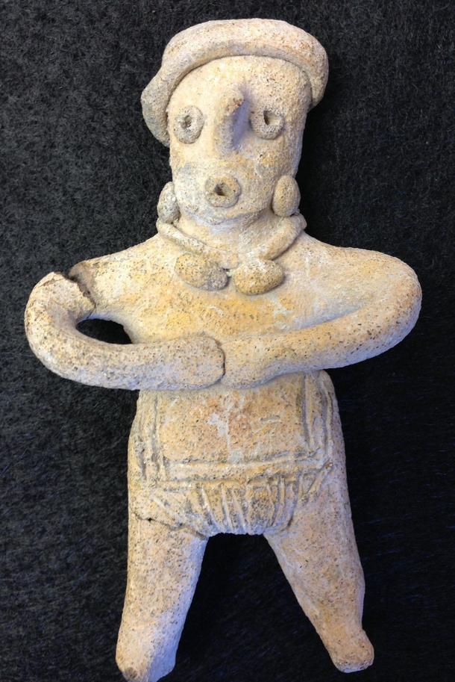

|  |  |
| --- | --- |
| ORDER DATEDec 08, 2015 | ORDER TOTAL  US $414.99  + US $15.50  shipping  **Order Pre Columbian Nayarit Warrior 8.5" in height** [Leave feedback - ORDER DATE Dec 08, 2015](http://feedback.ebay.com/ws/eBayISAPI.dll?LeaveFeedbackShow&useridto=thotho_clmt4tvg&transactID=0&item=291629480964&_trksid=p2057872.m2749.l2665)[View order details](http://payments.ebay.com/ws/eBayISAPI.dll?ViewPaymentStatus&transId=0&itemid=291629480964&_trksid=p2057872.m2749.l2673) - ORDER DATE Dec 08, 2015  [More actions - ORDER DATE Dec 08, 2015](http://www.ebay.com/myb/PurchaseHistory) |

1 item sold by [thotho_clmt4tvg](http://www.ebay.com/usr/thotho_clmt4tvg?_trksid=p2057872.m2749.l2754)

PRE-COLUMBIAN FEMALE FIGURE

Colima, Mexico, Shaft Tomb Culture

Circa 300 BC - 300 AD

Standing female figure, solid buff clay flat figure, 7-1/4" Ht.  Great details (earrings, necklace, turban, shoulder scarification).  Impressive size. Shows well.

Condition: Both arms have been restored with new clay fill.  Well done repair. Copious root marks and mineral deposits attest to age.

GUARANTEED AUTHENTIC

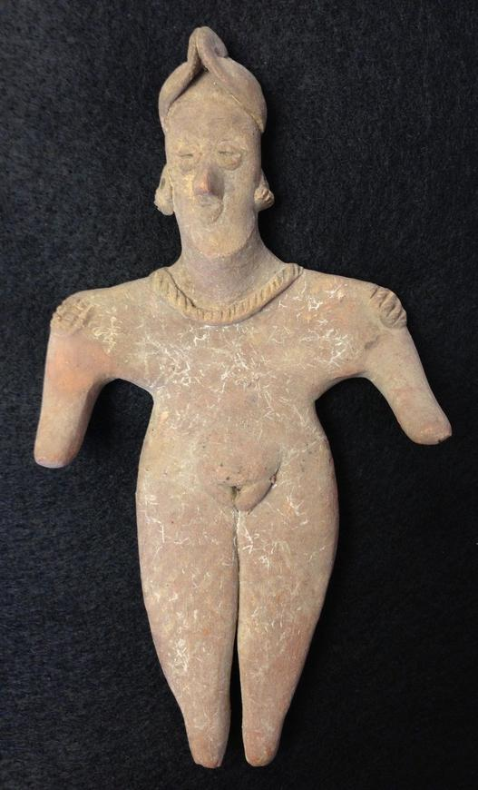

|  |  |  |  |
| --- | --- | --- | --- |
| [Pre Columbian Nayarit Warrior 8.5" in height](http://www.ebay.com/itm/291629480964?_trksid=p2057872.m2749.l2649&ssPageName=STRK%3AMEBIDX%3AIT)  ( 291629480964 )  Delivered on Fri, Dec 11  Tracking number: [**Tracking number**9410809699937144027613](javascript:;)  Pre Columbian, Nayarit Warrior holding a club and clothed in a loin cloth and Pancho. Good mineral deposits. Undamaged. 8.5" high. 5.5" wide. | | | |
|  | ORDER DATEDec 08, 2015 | ORDER TOTAL  US $325.00  + US $12.00  shipping  **Order Ancient Pre-Columbian Colima Pottery Seated Priest Pre-Columbia c.100 BC-250 AD** [Leave feedback - ORDER DATE Dec 08, 2015](http://feedback.ebay.com/ws/eBayISAPI.dll?LeaveFeedbackShow&useridto=palmyraheritagemorriskhouligallery&transactID=1565655758002&item=121766493297&_trksid=p2057872.m2749.l2665)[View order details](http://payments.ebay.com/ws/eBayISAPI.dll?ViewPaymentStatus&transId=1565655758002&itemid=121766493297&_trksid=p2057872.m2749.l2673) - ORDER DATE Dec 08, 2015  [More actions - ORDER DATE Dec 08, 2015](http://www.ebay.com/myb/PurchaseHistory) |  |

1 item sold by [palmyraheritagemorriskhouligallery](http://www.ebay.com/usr/palmyraheritagemorriskhouligallery?_trksid=p2057872.m2749.l2754)

|  |  |  |  |
| --- | --- | --- | --- |
| [Ancient Pre-Columbian Colima Pottery Seated Priest Pre-Columbia c.100 BC-250 AD](http://www.ebay.com/itm/121766493297?_trksid=p2057872.m2749.l2649&ssPageName=STRK%3AMEBIDX%3AIT)  ( 121766493297 )  Delivered on Fri, Dec 11  Tracking number: [**Tracking number**9405909699939503489310](javascript:;) | | | |
|  | ORDER DATEDec 05, 2015 | ORDER TOTAL  US $115.50  + US $14.99  shipping  **Order Large Mexican Art Pottery Mayan Aztec Clay Figurine Statue Terracotta Rare** [Leave feedback - ORDER DATE Dec 05, 2015](http://feedback.ebay.com/ws/eBayISAPI.dll?LeaveFeedbackShow&useridto=shweeshwee1&transactID=0&item=281869769930&_trksid=p2057872.m2749.l2665)[View order details](http://payments.ebay.com/ws/eBayISAPI.dll?ViewPaymentStatus&transId=0&itemid=281869769930&_trksid=p2057872.m2749.l2673) - ORDER DATE Dec 05, 2015  [More actions - ORDER DATE Dec 05, 2015](http://www.ebay.com/myb/PurchaseHistory) |  |

1 item sold by [shweeshwee1](http://www.ebay.com/usr/shweeshwee1?_trksid=p2057872.m2749.l2754)

|  |  |  |  |
| --- | --- | --- | --- |
| [Large Mexican Art Pottery Mayan Aztec Clay Figurine Statue Terracotta Rare](http://www.ebay.com/itm/281869769930?_trksid=p2057872.m2749.l2649&ssPageName=STRK%3AMEBIDX%3AIT)  ( 281869769930 )  Delivered on Sun, Dec 13  Tracking number: [**Tracking number**9405509699939502697466](javascript:;) | | | |
|  | ORDER DATEDec 04, 2015 | ORDER TOTAL  US $10.45  + US $5.95  shipping  **Order Antique Peruvian Chancay Burial Grave Latin American Folk Art Doll Primitive C** [Leave feedback - ORDER DATE Dec 04, 2015](http://feedback.ebay.com/ws/eBayISAPI.dll?LeaveFeedbackShow&useridto=pulykapipi&transactID=0&item=331720794805&_trksid=p2057872.m2749.l2665)[View order details](http://payments.ebay.com/ws/eBayISAPI.dll?ViewPaymentStatus&transId=0&itemid=331720794805&_trksid=p2057872.m2749.l2673) - ORDER DATE Dec 04, 2015  [More actions - ORDER DATE Dec 04, 2015](http://www.ebay.com/myb/PurchaseHistory) |  |

1 item sold by [pulykapipi](http://www.ebay.com/usr/pulykapipi?_trksid=p2057872.m2749.l2754)

|  |
| --- |
| [Antique Peruvian Chancay Burial Grave Latin American Folk Art Doll Primitive C](http://www.ebay.com/itm/331720794805?_trksid=p2057872.m2749.l2649&ssPageName=STRK%3AMEBIDX%3AIT)  ( 331720794805 )  Delivered on Wed, Dec 09  Tracking number: [**Tracking number**9405509699939491812987](javascript:;) |

1 CHANCAY MUMMY DOLL,  DATING FROM Early 20 th century.

 THE THREESOMES MEASURE APPROXIMATELY 8" X 6.5".  PLEASE SEE PHOTOS FOR ACCURATE DESCRIPTIONS AND CONDITION ASSESSMENT.  WE GLADLY ACCEPT PAYPAL, SHIP PROMPTLY UPON PAYMENT.  THANK YOU AND GOOD LUCK BIDDING!



[Native American - Two Spirit Ghost Dance Doll](http://www.ebay.com/itm/301812132613?_trksid=p2057872.m2749.l2649&ssPageName=STRK%3AMEBIDX%3AIT)

( 301812132613 )

Delivered on Tue, Dec 08

Tracking number: [**Tracking number**13150540000014045355](javascript:;)

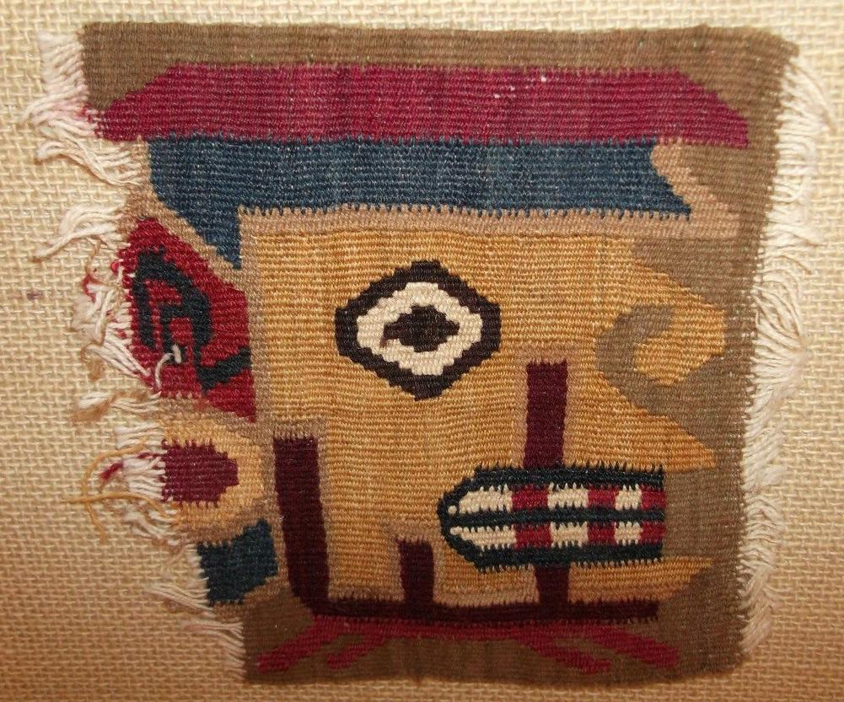

|  |  |
| --- | --- |
| ORDER DATEDec 02, 2015 | ORDER TOTAL  US $403.49  + US $95.00  shipping  **Order HUARI HUMAN FACE FRAGMENT, WOVEN IN MUSTARD, TEAL , MARRON COLORS BC , ORIGINAL, FRAGMENT PELICANS SEA, SOUTH NAZCA , WOVEN CAMEL FIBERS, COLORS , ORIGINAL,CHIMU CULTURE BLACKWARE ROUND VESSEL, TUMIS ENGRAVED ,CIRCA 1600 AD, , ORIGINAL,CHIMU/MOCHE .. CULTURE BLACKWARE WOMEN CIRCA 1600 AD, , ORIGINAL,CUCHIMILCO FIGURE HUACHO , PAINTED RED CHANCAY , CIRCA 1600 AD, TAN TERRACOTTA** [View order details - ORDER DATE Dec 02, 2015](http://payments.ebay.com/ws/eBayISAPI.dll?ViewPaymentStatus&transId=0&itemid=231762154247&_trksid=p2057872.m2749.l2673)[Contact seller](http://contact.ebay.com/ws/eBayISAPI.dll?ShowSellerFAQ&requested=artprimitivo&iid=231762154247&redirect=0&_trksid=p2057872.m2749.l2652) - ORDER DATE Dec 02, 2015  [More actions - ORDER DATE Dec 02, 2015](http://www.ebay.com/myb/PurchaseHistory) |

5 items sold by [artprimitivo](http://www.ebay.com/usr/artprimitivo?_trksid=p2057872.m2749.l2754)

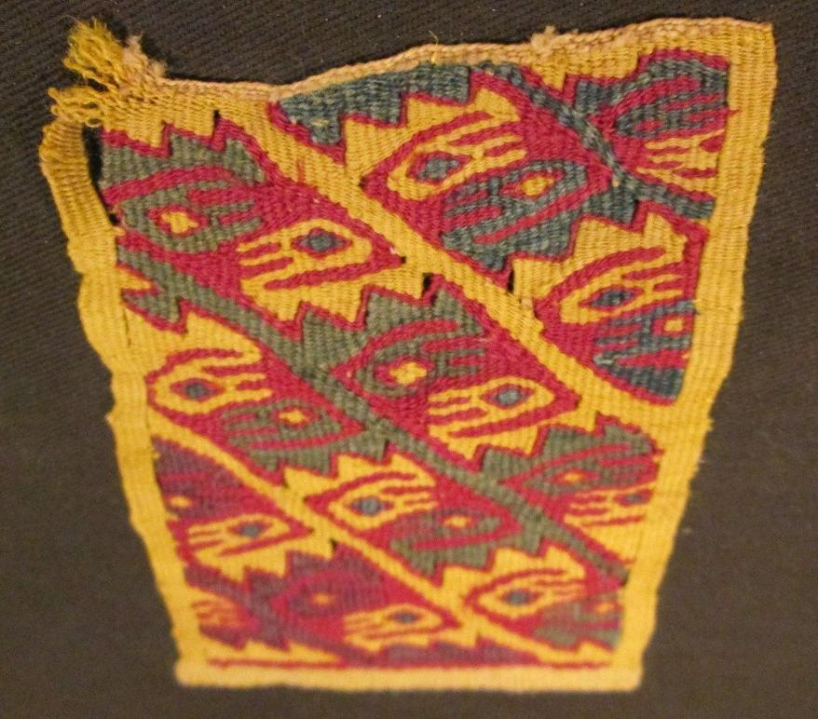 SMALL TEXTILE DEPICTS PELICANS ON SEQUENCE INVERTED, DIANGONAL ROWS OF VARIOUS PELICANS IN VIBRANT COLORS OF MUSTARD , BURGANDY AND TEAL

 FRAGMENT PELICANS SEA, SOUTH NAZ,  WOVEN  COLORS  WITH ZIG ZAG GEOMETRIC LINES, GRACIOUS PELICANS DEPICTS TEAL ALMOND SHAPE EYES, YELLOW BACKGROUND AND EDGES

MEASURES 4"X3" MOUNTED ON 10" WOOD AND BLACK CLOTH FRAME, SHOWS AGE, DISCOLORATION, FEW TEARS ON EDGES OF FRAGMENT, SPOTS, ANCIENT WEAR

RICH VIVID NATURAL SPECTACULAR COLORS, EXCEPTIONAL , SHOWS WELL, ALL UNIQUE ORIGINAL!! AND MOUNTED, READY FOR DISPLAY!

|  |  |  |
| --- | --- | --- |
| [HUARI HUMAN FACE FRAGMENT, WOVEN IN MUSTARD, TEAL , MARRON COLORS BC , ORIGINAL](http://www.ebay.com/itm/231762154247?_trksid=p2057872.m2749.l2649&ssPageName=STRK%3AMEBIDX%3AIT)  ( 231762154247 )  Estimated delivery Thu, Dec 10 - Mon, Dec 14  [Add note](javascript:;) | ITEM PRICE:  US $39.00 | **Item HUARI HUMAN FACE FRAGMENT, WOVEN IN MUSTARD, TEAL , MARRON COLORS BC , ORIGINAL Orders 231762154247-0-0**[Leave feedback](http://feedback.ebay.com/ws/eBayISAPI.dll?LeaveFeedbackShow&useridto=artprimitivo&transactID=0&item=231762154247&_trksid=p2057872.m2749.l2665)[Return this item](http://postorder.ebay.com/Return/ReturnViewSelectedItem?transactionId=0&itemId=231762154247&_trksid=p2057872.m2749.l3185)  [More actions](http://www.ebay.com/myb/PurchaseHistory) |

|  |  |
| --- | --- |
| ORDER DATEDec 02, 2015 | ORDER TOTAL  US $84.00  + US $8.50  shipping  **Order Colima Pre-Colombian Pottery Unusual Dog Licking Face** [Leave feedback - ORDER DATE Dec 02, 2015](http://feedback.ebay.com/ws/eBayISAPI.dll?LeaveFeedbackShow&useridto=indyblueco&transactID=0&item=252186006998&_trksid=p2057872.m2749.l2665)[View order details](http://payments.ebay.com/ws/eBayISAPI.dll?ViewPaymentStatus&transId=0&itemid=252186006998&_trksid=p2057872.m2749.l2673) - ORDER DATE Dec 02, 2015  [More actions - ORDER DATE Dec 02, 2015](http://www.ebay.com/myb/PurchaseHistory) |

1 item sold by [indyblueco](http://www.ebay.com/usr/indyblueco?_trksid=p2057872.m2749.l2754)

|  |
| --- |
|  |

4 1/2" x 2 3/4"

Woman holding dog. Licking face.

Nick on dog please look carefully at pictures this is a prehistoric artifact and is not in pristine condition.

Some nicks not mentioned may be present.

|  |  |
| --- | --- |
| ORDER DATEDec 01, 2015 | ORDER TOTAL  US $393.57  + US $33.00  shipping  **Order Precolumbian Vera Cruz Head Mounted,Precolumbian LaTolita Head Mounted,Precolumbian Colima Platform/litter figure ,Two Large Seated Precolumbian Colima Figures 6" high X 4" across,Precolumbian painted Nayarit figure** [View order details - ORDER DATE Dec 01, 2015](http://payments.ebay.com/ws/eBayISAPI.dll?ViewPaymentStatus&transId=0&itemid=172009505978&_trksid=p2057872.m2749.l2673)[Contact seller](http://contact.ebay.com/ws/eBayISAPI.dll?ShowSellerFAQ&requested=precolumbianrelics&iid=172009505978&redirect=0&_trksid=p2057872.m2749.l2652) - ORDER DATE Dec 01, 2015  [More actions - ORDER DATE Dec 01, 2015](http://www.ebay.com/myb/PurchaseHistory) |

5 items sold by [precolumbianrelics](http://www.ebay.com/usr/precolumbianrelics?_trksid=p2057872.m2749.l2754)

|  |  |  |
| --- | --- | --- |
| [Precolumbian Vera Cruz Head Mounted](http://www.ebay.com/itm/172009505978?_trksid=p2057872.m2749.l2649&ssPageName=STRK%3AMEBIDX%3AIT)  ( 172009505978 )  Estimated delivery Mon, Dec 07  [Add note](javascript:;) | ITEM PRICE:  US $66.57 | **Item Precolumbian Vera Cruz Head Mounted Orders 172009505978-0-0**[Leave feedback](http://feedback.ebay.com/ws/eBayISAPI.dll?LeaveFeedbackShow&useridto=precolumbianrelics&transactID=0&item=172009505978&_trksid=p2057872.m2749.l2665)[Return this item](http://postorder.ebay.com/Return/ReturnViewSelectedItem?transactionId=0&itemId=172009505978&_trksid=p2057872.m2749.l3185)  [More actions](http://www.ebay.com/myb/PurchaseHistory) |

|  |  |  |
| --- | --- | --- |
| [Precolumbian LaTolita Head Mounted](http://www.ebay.com/itm/172009507077?_trksid=p2057872.m2749.l2649&ssPageName=STRK%3AMEBIDX%3AIT)  ( 172009507077 )  Estimated delivery Mon, Dec 07  [Add note](javascript:;) | ITEM PRICE:  US $49.00 | **Item Precolumbian LaTolita Head Mounted Orders 172009507077-0-0**[Leave feedback](http://feedback.ebay.com/ws/eBayISAPI.dll?LeaveFeedbackShow&useridto=precolumbianrelics&transactID=0&item=172009507077&_trksid=p2057872.m2749.l2665)[Return this item](http://postorder.ebay.com/Return/ReturnViewSelectedItem?transactionId=0&itemId=172009507077&_trksid=p2057872.m2749.l3185)  [More actions](http://www.ebay.com/myb/PurchaseHistory) |

|  |  |  |
| --- | --- | --- |
| [Precolumbian Colima Platform/litter figure](http://www.ebay.com/itm/172009524558?_trksid=p2057872.m2749.l2649&ssPageName=STRK%3AMEBIDX%3AIT)  ( 172009524558 )  Estimated delivery Mon, Dec 07  [Add note](javascript:;) | ITEM PRICE:  US $91.00 | **Item Precolumbian Colima Platform/litter figure Orders 172009524558-0-0**[Leave feedback](http://feedback.ebay.com/ws/eBayISAPI.dll?LeaveFeedbackShow&useridto=precolumbianrelics&transactID=0&item=172009524558&_trksid=p2057872.m2749.l2665)[Return this item](http://postorder.ebay.com/Return/ReturnViewSelectedItem?transactionId=0&itemId=172009524558&_trksid=p2057872.m2749.l3185)  [More actions](http://www.ebay.com/myb/PurchaseHistory) |

|  |  |  |
| --- | --- | --- |
| [Two Large Seated Precolumbian Colima Figures 6" high X 4" across](http://www.ebay.com/itm/172009525529?_trksid=p2057872.m2749.l2649&ssPageName=STRK%3AMEBIDX%3AIT)  ( 172009525529 )  Estimated delivery Mon, Dec 07  [Add note](javascript:;) | ITEM PRICE:  US $129.00 | **Item Two Large Seated Precolumbian Colima Figures 6" high X 4" across Orders 172009525529-0-0**[Leave feedback](http://feedback.ebay.com/ws/eBayISAPI.dll?LeaveFeedbackShow&useridto=precolumbianrelics&transactID=0&item=172009525529&_trksid=p2057872.m2749.l2665)[Return this item](http://postorder.ebay.com/Return/ReturnViewSelectedItem?transactionId=0&itemId=172009525529&_trksid=p2057872.m2749.l3185)  [More actions](http://www.ebay.com/myb/PurchaseHistory) |

|  |  |  |
| --- | --- | --- |
| [Precolumbian painted Nayarit figure](http://www.ebay.com/itm/172009526092?_trksid=p2057872.m2749.l2649&ssPageName=STRK%3AMEBIDX%3AIT)  ( 172009526092 )  Estimated delivery Mon, Dec 07  [Add note](javascript:;) | ITEM PRICE:  US $58.00 | **Item Precolumbian painted Nayarit figure Orders 172009526092-0-0**[Leave feedback](http://feedback.ebay.com/ws/eBayISAPI.dll?LeaveFeedbackShow&useridto=precolumbianrelics&transactID=0&item=172009526092&_trksid=p2057872.m2749.l2665)[Return this item](http://postorder.ebay.com/Return/ReturnViewSelectedItem?transactionId=0&itemId=172009526092&_trksid=p2057872.m2749.l3185)  [More actions](http://www.ebay.com/myb/PurchaseHistory) |

|  |  |
| --- | --- |
| ORDER DATEDec 01, 2015 | ORDER TOTAL  US $67.00  + US $3.94  shipping  **Order Pre-Columbian Figure Whistle * Painted * Sitting Person \*** [Leave feedback - ORDER DATE Dec 01, 2015](http://feedback.ebay.com/ws/eBayISAPI.dll?LeaveFeedbackShow&useridto=earthdogmb-merch&transactID=0&item=301807675741&_trksid=p2057872.m2749.l2665)[View order details](http://payments.ebay.com/ws/eBayISAPI.dll?ViewPaymentStatus&transId=0&itemid=301807675741&_trksid=p2057872.m2749.l2673) - ORDER DATE Dec 01, 2015  [More actions - ORDER DATE Dec 01, 2015](http://www.ebay.com/myb/PurchaseHistory) |

1 item sold by [earthdogmb-merch](http://www.ebay.com/usr/earthdogmb-merch?_trksid=p2057872.m2749.l2754)

|  |  |  |
| --- | --- | --- |
| [Pre-Columbian Figure Whistle * Painted * Sitting Person *](http://www.ebay.com/itm/301807675741?_trksid=p2057872.m2749.l2649&ssPageName=STRK%3AMEBIDX%3AIT)  ( 301807675741 )  Delivered on Sun, Dec 06  Tracking number: [**Tracking number**9400111899223310223190](javascript:;)  [Add note](javascript:;) | ITEM PRICE:  US $67.00 |  |

|  |  |
| --- | --- |
| ORDER DATEDec 01, 2015 | ORDER TOTAL  US $75.00  + US $7.95  shipping  **Order PRE-COLUMBIAN CHANCAY PERUVIAN TEXTILE FRAGMENT IN SILVER & WOOD BOX** [Leave feedback - ORDER DATE Dec 01, 2015](http://feedback.ebay.com/ws/eBayISAPI.dll?LeaveFeedbackShow&useridto=oldbostonian&transactID=0&item=301807595754&_trksid=p2057872.m2749.l2665)[View order details](http://payments.ebay.com/ws/eBayISAPI.dll?ViewPaymentStatus&transId=0&itemid=301807595754&_trksid=p2057872.m2749.l2673) - ORDER DATE Dec 01, 2015  [More actions - ORDER DATE Dec 01, 2015](http://www.ebay.com/myb/PurchaseHistory) |

1 item sold by [oldbostonian](http://www.ebay.com/usr/oldbostonian?_trksid=p2057872.m2749.l2754)

|  |  |
| --- | --- |
| [PRE-COLUMBIAN CHANCAY PERUVIAN TEXTILE FRAGMENT IN SILVER & WOOD BOX](http://www.ebay.com/itm/301807595754?_trksid=p2057872.m2749.l2649&ssPageName=STRK%3AMEBIDX%3AIT)  ( 301807595754 )  Delivered on Wed, Dec 02  Tracking number: [**Tracking number**9405509699937116131437](javascript:;)  [Add note](javascript:;) | ITEM PRICE:  US $75.00 |

|  |  |  |
| --- | --- | --- |
| [FRAGMENT PELICANS SEA, SOUTH NAZCA , WOVEN CAMEL FIBERS, COLORS , ORIGINAL](http://www.ebay.com/itm/231762160256?_trksid=p2057872.m2749.l2649&ssPageName=STRK%3AMEBIDX%3AIT)  ( 231762160256 )  Estimated delivery Thu, Dec 10 - Mon, Dec 14  [Add note](javascript:;) | ITEM PRICE:  US $84.99 | **Item FRAGMENT PELICANS SEA, SOUTH NAZCA , WOVEN CAMEL FIBERS, COLORS , ORIGINAL Orders 231762160256-0-0**[Leave feedback](http://feedback.ebay.com/ws/eBayISAPI.dll?LeaveFeedbackShow&useridto=artprimitivo&transactID=0&item=231762160256&_trksid=p2057872.m2749.l2665)[Return this item](http://postorder.ebay.com/Return/ReturnViewSelectedItem?transactionId=0&itemId=231762160256&_trksid=p2057872.m2749.l3185)  [More actions](http://www.ebay.com/myb/PurchaseHistory) |

|  |  |  |
| --- | --- | --- |
| [CHIMU CULTURE BLACKWARE ROUND VESSEL, TUMIS ENGRAVED ,CIRCA 1600 AD, , ORIGINAL](http://www.ebay.com/itm/231762181997?_trksid=p2057872.m2749.l2649&ssPageName=STRK%3AMEBIDX%3AIT)  ( 231762181997 )  Estimated delivery Fri, Dec 11 - Tue, Dec 15  [Add note](javascript:;) | ITEM PRICE:  US $96.00 | **Item CHIMU CULTURE BLACKWARE ROUND VESSEL, TUMIS ENGRAVED ,CIRCA 1600 AD, , ORIGINAL Orders 231762181997-0-0**[Leave feedback](http://feedback.ebay.com/ws/eBayISAPI.dll?LeaveFeedbackShow&useridto=artprimitivo&transactID=0&item=231762181997&_trksid=p2057872.m2749.l2665)[Return this item](http://postorder.ebay.com/Return/ReturnViewSelectedItem?transactionId=0&itemId=231762181997&_trksid=p2057872.m2749.l3185)  [More actions](http://www.ebay.com/myb/PurchaseHistory) |

|  |  |  |
| --- | --- | --- |
| [CHIMU/MOCHE .. CULTURE BLACKWARE WOMEN CIRCA 1600 AD, , ORIGINAL](http://www.ebay.com/itm/231762195485?_trksid=p2057872.m2749.l2649&ssPageName=STRK%3AMEBIDX%3AIT)  ( 231762195485 )  Estimated delivery Thu, Dec 10 - Mon, Dec 14  [Add note](javascript:;) | ITEM PRICE:  US $66.00 | **Item CHIMU/MOCHE .. CULTURE BLACKWARE WOMEN CIRCA 1600 AD, , ORIGINAL Orders 231762195485-0-0**[Leave feedback](http://feedback.ebay.com/ws/eBayISAPI.dll?LeaveFeedbackShow&useridto=artprimitivo&transactID=0&item=231762195485&_trksid=p2057872.m2749.l2665)[Return this item](http://postorder.ebay.com/Return/ReturnViewSelectedItem?transactionId=0&itemId=231762195485&_trksid=p2057872.m2749.l3185)  [More actions](http://www.ebay.com/myb/PurchaseHistory)  CHIMU BLACKWARE VESSLE,  CIRCA 1600 AD,  TERRACOTTA BLACK GLAZED CERAMIC, SHOWS DENDRITES , FUNGUS, HAIRLINES, GLOBULAR BODY., WITH STIRRUP SPOUTE  DEPICTS ENGRAVED  LARGE TUMI ON BOTH SIDES, ONE STANDING FIGURE OF TUMI, WEARING AN ORNAMENTAL LARGE HEADRESS, WITH SUN ON CENTER AND SNAKES ON BOTH SIDES  OF HALF MOOM HEADRESS, TUMI HOLDING ZOOMORPHIC FIGURES WITH BOTH HANDS  OTHER SIDE TUMI IS STANDING FIRM ON SEPARATED LEGS , HOLDING PLANTS, OR ARMED.?, SURROUNDED WITH ZOOMORPHIC DEITIES ON BOTH SIDES, WEARING HEADRESS  SPOUTED STIRRUP, MOUNTED MONKEY CURLED UP ON ONE SIDE OF SPOUTE, HOLDS SPOUTE   ROUND VESSEL, TUMIS ENGRAVED ,CIRCA 1600 AD, , ORIGINAL NORTH COAST, BROKEN,MISSING,  SPOUT BROKEN , SHOWNS DENDRITES, CRACK HAIRLINES, NICKS ,  ORIGINAL  AMAZING INTRICATED RELIEF OF DESIGNS, INTERPRETING HISTORY AND LIFE OF THE PRECOLUMBIAN CHIMU NORTH COAST |

|  |  |  |  |
| --- | --- | --- | --- |
| [CUCHIMILCO FIGURE HUACHO , PAINTED RED CHANCAY , CIRCA 1600 AD, TAN TERRACOTTA](http://www.ebay.com/itm/231762203189?_trksid=p2057872.m2749.l2649&ssPageName=STRK%3AMEBIDX%3AIT)  ( 231762203189 )  Estimated delivery Thu, Dec 10 - Mon, Dec 14  CHIMU BLACKWARE VESSLE,  CIRCA 1600 AD,  TERRACOTTA BLACK GLAZED CERAMIC,   SHOWS DENDRITES , FUNGUS, HAIRLINES, GLOBULAR BODY.CHIMU/MOCHE .. CULTURE BLACKWARE WOMEN , SHE IS CARRYNG HEAVY LOAD, PEASANT CHEWING COCA LEAVES,  CIRCA 1600 AD, , ORIGINAL  DEPICTS GLOBULAR LARGE BODY, CARRYNG HEAVY LOAD, ROUGH LOOK , CHUNKY PORTRUDING DEFORMED LARGE NOSE, ALMOND EYES, SLIT LIPS, OPEN STIRRUP SPOUTE, WITH STRAP HANDLE  MEASURES 10"HEIGHT  SHOWNS DENDRITES, CRACK HAIRLINES, NICKS ,  ORIGINAL | | | |
|  |  | |  |  | | --- | --- | | |  | | --- | | CHANCAY CUCHIMILCO FIGURE  HUACHO ,   PAINTED  RED FACE,  LARGE NOSE, ROUNDED EYES, TINY MOUTH, DEEP BROWN PAINTED HANDS, DECORATION ON BOTH LEGS, LINEAR PAINTED TRACES,  WEARS LARGE HEADRESS, PAINTED IN VERTICAL BURGANDY, BROWN TAN LINES, OPEN ARMS , STANDING WITH TWO SEPARATED FEET,  CHANCAY , CIRCA 1600  MEASURES 10" HEIGHT  NORTH COAST, , SHOWNS DENDRITES, CRACK HAIRLINES, NICKS ,  ORIGINAL !!  GREAT CONVERSATION PIECE OF HISTORY, DISPLAY PIECE FOR YOUR COLLECTION, OR DECORATION | | |  |

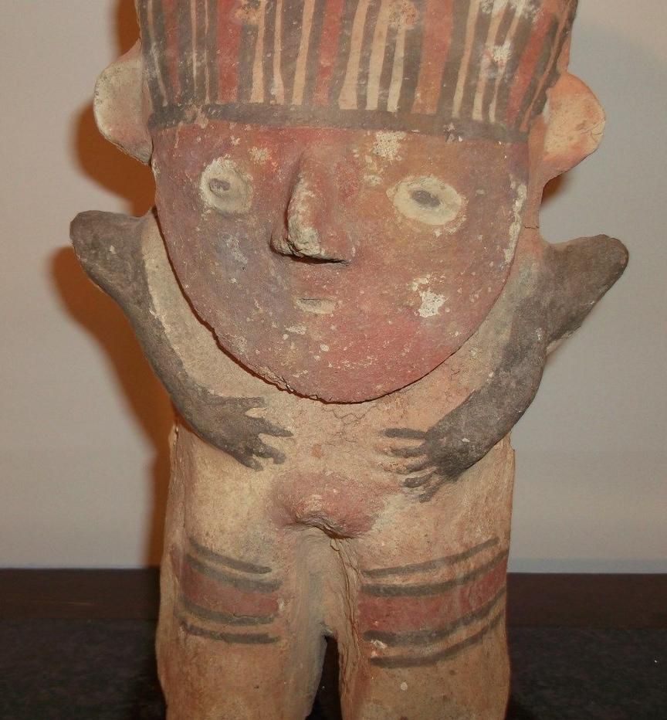

|  |  |
| --- | --- |
| ORDER DATEDec 01, 2015 | ORDER TOTAL  US $100.00  + US $7.00  shipping  **Order OUTSTANDING COLIMA FIGURE** [Leave feedback - ORDER DATE Dec 01, 2015](http://feedback.ebay.com/ws/eBayISAPI.dll?LeaveFeedbackShow&useridto=crewzzen&transactID=1309909882010&item=201442158608&_trksid=p2057872.m2749.l2665)[View order details](http://payments.ebay.com/ws/eBayISAPI.dll?ViewPaymentStatus&transId=1309909882010&itemid=201442158608&_trksid=p2057872.m2749.l2673) - ORDER DATE Dec 01, 2015  [More actions - ORDER DATE Dec 01, 2015](http://www.ebay.com/myb/PurchaseHistory) |

1 item sold by [crewzzen](http://www.ebay.com/usr/crewzzen?_trksid=p2057872.m2749.l2754)

|  |  |  |  |  |  |
| --- | --- | --- | --- | --- | --- |
| [OUTSTANDING COLIMA FIGURE](http://www.ebay.com/itm/201442158608?_trksid=p2057872.m2749.l2649&ssPageName=STRK%3AMEBIDX%3AIT)  ( 201442158608 )  Delivered on Sat, Dec 19  Tracking number: [**Tracking number**9410809699938040887813](javascript:;)  [Add note](javascript:;) | | | | ITEM PRICE:  US $100.00 |  |
|  | ORDER DATENov 30, 2015 | ORDER TOTAL  US $69.00  + US $30.00  shipping  **Order TOP CHOICE CHALCEDONY FLOWER WITH RED STILBITE ON CHALCEDONY SPECIMENS ,STUNNING THOMSONITE BALL SPECIMENS ,PRETTY GLASSY MICRO RED STILBITE ON CHALCEDONY SPECIMENS ,STUNNING GLASSY RED HEULANDITE SPECIMENS ,STUNNING RED STILBITE ON CHALCEDONY SPECIMENS ,SUPERB FORMATION GREEN APOPHYLLITE &SCOLECITE w/ STILBITE ON CHALCEDO SPECIMENS ,CLASSICAL FORMATION GREEN APOPHYLLITE ON MORDENITE FLOWER SPECIMENS** [View order details - ORDER DATE Nov 30, 2015](http://payments.ebay.com/ws/eBayISAPI.dll?ViewPaymentStatus&transId=1208427188009&itemid=191728064670&_trksid=p2057872.m2749.l2673)[Contact seller](http://contact.ebay.com/ws/eBayISAPI.dll?ShowSellerFAQ&requested=gouriminerals2011&iid=191728064670&redirect=0&_trksid=p2057872.m2749.l2652) - ORDER DATE Nov 30, 2015  [More actions - ORDER DATE Nov 30, 2015](http://www.ebay.com/myb/PurchaseHistory) |  | | |

7 items sold by [gouriminerals2011](http://www.ebay.com/usr/gouriminerals2011?_trksid=p2057872.m2749.l2754)

|  |  |  |
| --- | --- | --- |
| [TOP CHOICE CHALCEDONY FLOWER WITH RED STILBITE ON CHALCEDONY SPECIMENS](http://www.ebay.com/itm/191728064670?_trksid=p2057872.m2749.l2649&ssPageName=STRK%3AMEBIDX%3AIT)  ( 191728064670 )  Delivered on Tue, Dec 15  Tracking number: [**Tracking number**CM412712675IN](javascript:;)  [Add note](javascript:;) | ITEM PRICE:  US $15.00 | **Item TOP CHOICE CHALCEDONY FLOWER WITH RED STILBITE ON CHALCEDONY SPECIMENS Orders 191728064670-0-1208427188009**[Leave feedback](http://feedback.ebay.com/ws/eBayISAPI.dll?LeaveFeedbackShow&useridto=gouriminerals2011&transactID=1208427188009&item=191728064670&_trksid=p2057872.m2749.l2665)[Return this item](http://postorder.ebay.com/Return/ReturnViewSelectedItem?transactionId=1208427188009&itemId=191728064670&_trksid=p2057872.m2749.l3185)  [More actions](http://www.ebay.com/myb/PurchaseHistory) |

|  |  |  |
| --- | --- | --- |
| [STUNNING THOMSONITE BALL SPECIMENS](http://www.ebay.com/itm/191746566552?_trksid=p2057872.m2749.l2649&ssPageName=STRK%3AMEBIDX%3AIT)  ( 191746566552 )  Delivered on Tue, Dec 15  Tracking number: [**Tracking number**CM412712675IN](javascript:;)  [Add note](javascript:;) | ITEM PRICE:  US $3.00 | **Item STUNNING THOMSONITE BALL SPECIMENS Orders 191746566552-0-1208427187009**[Leave feedback](http://feedback.ebay.com/ws/eBayISAPI.dll?LeaveFeedbackShow&useridto=gouriminerals2011&transactID=1208427187009&item=191746566552&_trksid=p2057872.m2749.l2665)[Return this item](http://postorder.ebay.com/Return/ReturnViewSelectedItem?transactionId=1208427187009&itemId=191746566552&_trksid=p2057872.m2749.l3185)  [More actions](http://www.ebay.com/myb/PurchaseHistory) |

|  |  |  |
| --- | --- | --- |
| [PRETTY GLASSY MICRO RED STILBITE ON CHALCEDONY SPECIMENS](http://www.ebay.com/itm/191746930131?_trksid=p2057872.m2749.l2649&ssPageName=STRK%3AMEBIDX%3AIT)  ( 191746930131 )  Delivered on Tue, Dec 15  Tracking number: [**Tracking number**CM412712675IN](javascript:;)  [Add note](javascript:;) | ITEM PRICE:  US $3.00 | **Item PRETTY GLASSY MICRO RED STILBITE ON CHALCEDONY SPECIMENS Orders 191746930131-0-1208427189009**[Leave feedback](http://feedback.ebay.com/ws/eBayISAPI.dll?LeaveFeedbackShow&useridto=gouriminerals2011&transactID=1208427189009&item=191746930131&_trksid=p2057872.m2749.l2665)[Return this item](http://postorder.ebay.com/Return/ReturnViewSelectedItem?transactionId=1208427189009&itemId=191746930131&_trksid=p2057872.m2749.l3185)  [More actions](http://www.ebay.com/myb/PurchaseHistory) |

|  |  |  |
| --- | --- | --- |
| [STUNNING GLASSY RED HEULANDITE SPECIMENS](http://www.ebay.com/itm/191747250022?_trksid=p2057872.m2749.l2649&ssPageName=STRK%3AMEBIDX%3AIT)  ( 191747250022 )  Delivered on Tue, Dec 15  Tracking number: [**Tracking number**CM412712675IN](javascript:;)  [Add note](javascript:;) | ITEM PRICE:  US $15.00 | **Item STUNNING GLASSY RED HEULANDITE SPECIMENS Orders 191747250022-0-1208427190009**[Leave feedback](http://feedback.ebay.com/ws/eBayISAPI.dll?LeaveFeedbackShow&useridto=gouriminerals2011&transactID=1208427190009&item=191747250022&_trksid=p2057872.m2749.l2665)[Return this item](http://postorder.ebay.com/Return/ReturnViewSelectedItem?transactionId=1208427190009&itemId=191747250022&_trksid=p2057872.m2749.l3185)  [More actions](http://www.ebay.com/myb/PurchaseHistory) |

|  |  |  |
| --- | --- | --- |
| [STUNNING RED STILBITE ON CHALCEDONY SPECIMENS](http://www.ebay.com/itm/201473981246?_trksid=p2057872.m2749.l2649&ssPageName=STRK%3AMEBIDX%3AIT)  ( 201473981246 )  Delivered on Tue, Dec 15  Tracking number: [**Tracking number**CM412712675IN](javascript:;)  [Add note](javascript:;) | ITEM PRICE:  US $3.00 | **Item STUNNING RED STILBITE ON CHALCEDONY SPECIMENS Orders 201473981246-0-1309374835010**[Leave feedback](http://feedback.ebay.com/ws/eBayISAPI.dll?LeaveFeedbackShow&useridto=gouriminerals2011&transactID=1309374835010&item=201473981246&_trksid=p2057872.m2749.l2665)[Return this item](http://postorder.ebay.com/Return/ReturnViewSelectedItem?transactionId=1309374835010&itemId=201473981246&_trksid=p2057872.m2749.l3185)  [More actions](http://www.ebay.com/myb/PurchaseHistory) |

|  |  |  |
| --- | --- | --- |
| [SUPERB FORMATION GREEN APOPHYLLITE &SCOLECITE w/ STILBITE ON CHALCEDO SPECIMENS](http://www.ebay.com/itm/201473981380?_trksid=p2057872.m2749.l2649&ssPageName=STRK%3AMEBIDX%3AIT)  ( 201473981380 )  Delivered on Tue, Dec 15  Tracking number: [**Tracking number**CM412712675IN](javascript:;)  [Add note](javascript:;) | ITEM PRICE:  US $25.00 | **Item SUPERB FORMATION GREEN APOPHYLLITE &SCOLECITE w/ STILBITE ON CHALCEDO SPECIMENS Orders 201473981380-0-1309374836010**[Leave feedback](http://feedback.ebay.com/ws/eBayISAPI.dll?LeaveFeedbackShow&useridto=gouriminerals2011&transactID=1309374836010&item=201473981380&_trksid=p2057872.m2749.l2665)[Return this item](http://postorder.ebay.com/Return/ReturnViewSelectedItem?transactionId=1309374836010&itemId=201473981380&_trksid=p2057872.m2749.l3185)  [More actions](http://www.ebay.com/myb/PurchaseHistory) |

|  |  |  |
| --- | --- | --- |
| [CLASSICAL FORMATION GREEN APOPHYLLITE ON MORDENITE FLOWER SPECIMENS](http://www.ebay.com/itm/201473988827?_trksid=p2057872.m2749.l2649&ssPageName=STRK%3AMEBIDX%3AIT)  ( 201473988827 )  Delivered on Tue, Dec 15  Tracking number: [**Tracking number**CM412712675IN](javascript:;)  [Add note](javascript:;) | ITEM PRICE:  US $5.00 | **Item CLASSICAL FORMATION GREEN APOPHYLLITE ON MORDENITE FLOWER SPECIMENS Orders 201473988827-0-1309374833010**[Leave feedback](http://feedback.ebay.com/ws/eBayISAPI.dll?LeaveFeedbackShow&useridto=gouriminerals2011&transactID=1309374833010&item=201473988827&_trksid=p2057872.m2749.l2665)[Return this item](http://postorder.ebay.com/Return/ReturnViewSelectedItem?transactionId=1309374833010&itemId=201473988827&_trksid=p2057872.m2749.l3185)  [More actions](http://www.ebay.com/myb/PurchaseHistory) |

|  |  |
| --- | --- |
| ORDER DATENov 30, 2015 | ORDER TOTAL  US $16.90  + US $4.00  shipping  **Order Botryoidal - Blue Azurite on Green Malachite B1458 China** [Leave feedback - ORDER DATE Nov 30, 2015](http://feedback.ebay.com/ws/eBayISAPI.dll?LeaveFeedbackShow&useridto=chinesemineral.cn&transactID=1337341059006&item=161890684732&_trksid=p2057872.m2749.l2665)[View order details](http://payments.ebay.com/ws/eBayISAPI.dll?ViewPaymentStatus&transId=1337341059006&itemid=161890684732&_trksid=p2057872.m2749.l2673) - ORDER DATE Nov 30, 2015  [More actions - ORDER DATE Nov 30, 2015](http://www.ebay.com/myb/PurchaseHistory) |

1 item sold by [chinesemineral.cn](http://www.ebay.com/usr/chinesemineral.cn?_trksid=p2057872.m2749.l2754)

|  |  |  |
| --- | --- | --- |
| [Botryoidal - Blue Azurite on Green Malachite B1458 China](http://www.ebay.com/itm/161890684732?_trksid=p2057872.m2749.l2649&ssPageName=STRK%3AMEBIDX%3AIT)  ( 161890684732 )  Delivered on Thu, Dec 10  Tracking number: [**Tracking number**LK700443351CN](javascript:;)  [Add note](javascript:;) | ITEM PRICE:  US $16.90 |  |

|  |  |
| --- | --- |
| ORDER DATENov 30, 2015 | ORDER TOTAL  US $6.00  See description  **Order 40 Gram 1.4 Oz Crystal / Mineral Mounting Tack / Putty** [Leave feedback - ORDER DATE Nov 30, 2015](http://feedback.ebay.com/ws/eBayISAPI.dll?LeaveFeedbackShow&useridto=bmscrystals&transactID=1457033928018&item=281570365280&_trksid=p2057872.m2749.l2665)[View order details](http://payments.ebay.com/ws/eBayISAPI.dll?ViewPaymentStatus&transId=1457033928018&itemid=281570365280&_trksid=p2057872.m2749.l2673) - ORDER DATE Nov 30, 2015  [More actions - ORDER DATE Nov 30, 2015](http://www.ebay.com/myb/PurchaseHistory) |

1 item sold by [bmscrystals](http://www.ebay.com/usr/bmscrystals?_trksid=p2057872.m2749.l2754)

|  |  |  |
| --- | --- | --- |
| [40 Gram 1.4 Oz Crystal / Mineral Mounting Tack / Putty](http://www.ebay.com/itm/281570365280?_trksid=p2057872.m2749.l2649&ssPageName=STRK%3AMEBIDX%3AIT)  ( 281570365280 )  Delivered on Mon, Dec 07  Tracking number: [**Tracking number**9400111899563579708626](javascript:;)  [Add note](javascript:;) | ITEM PRICE:  US $6.00 |  |

|  |  |
| --- | --- |
| ORDER DATENov 30, 2015 | ORDER TOTAL  US $19.99  + US $3.95  shipping  **Order BIG SUPER NICE Elrathia Trilobite Fossil ! Cambrian Era Matrix Utah 227gr *G** [Leave feedback - ORDER DATE Nov 30, 2015](http://feedback.ebay.com/ws/eBayISAPI.dll?LeaveFeedbackShow&useridto=earths.ancient.gifts&transactID=1215031558014&item=331716929364&_trksid=p2057872.m2749.l2665)[View order details](http://payments.ebay.com/ws/eBayISAPI.dll?ViewPaymentStatus&transId=1215031558014&itemid=331716929364&_trksid=p2057872.m2749.l2673) - ORDER DATE Nov 30, 2015  [More actions - ORDER DATE Nov 30, 2015](http://www.ebay.com/myb/PurchaseHistory) |

1 item sold by [earths.ancient.gifts](http://www.ebay.com/usr/earths.ancient.gifts?_trksid=p2057872.m2749.l2754)

|  |  |  |
| --- | --- | --- |
| [BIG SUPER NICE Elrathia Trilobite Fossil ! Cambrian Era Matrix Utah 227gr *G](http://www.ebay.com/itm/331716929364?_trksid=p2057872.m2749.l2649&ssPageName=STRK%3AMEBIDX%3AIT)  ( 331716929364 )  Delivered on Thu, Dec 03  Tracking number: [**Tracking number**9400109699938988770004](javascript:;)  [Add note](javascript:;) | ITEM PRICE:  US $19.99 |  |

|  |  |
| --- | --- |
| ORDER DATENov 30, 2015 | ORDER TOTAL  US $24.00  + US $8.00  shipping  **Order B703- CLASSIC CAMBRIAN TRILOBITE Ellipsocephalus sp. - Czech Republic** [Leave feedback - ORDER DATE Nov 30, 2015](http://feedback.ebay.com/ws/eBayISAPI.dll?LeaveFeedbackShow&useridto=mido57&transactID=719697002023&item=361269098731&_trksid=p2057872.m2749.l2665)[View order details](http://payments.ebay.com/ws/eBayISAPI.dll?ViewPaymentStatus&transId=719697002023&itemid=361269098731&_trksid=p2057872.m2749.l2673) - ORDER DATE Nov 30, 2015  [More actions - ORDER DATE Nov 30, 2015](http://www.ebay.com/myb/PurchaseHistory) |

1 item sold by [mido57](http://www.ebay.com/usr/mido57?_trksid=p2057872.m2749.l2754)

|  |  |  |
| --- | --- | --- |
| [B703- CLASSIC CAMBRIAN TRILOBITE Ellipsocephalus sp. - Czech Republic](http://www.ebay.com/itm/361269098731?_trksid=p2057872.m2749.l2649&ssPageName=STRK%3AMEBIDX%3AIT)  ( 361269098731 )  Estimated delivery Thu, Dec 10 - Tue, Dec 22  [Add note](javascript:;) | ITEM PRICE:  US $24.00 |  |

|  |  |  |  |
| --- | --- | --- | --- |
| ORDER DATE | | | |
|  | RDER DATENov 29, 2015 | ORDER TOTAL  US $78.00  + US $11.10  shipping  **Order Meionite crystal mineral specimen, Franklin, NJ,Wollastonite fluorescent mineral from Sterling Hill Mine, near Franklin, NJ** [View order details - ORDER DATE Nov 29, 2015](http://payments.ebay.com/ws/eBayISAPI.dll?ViewPaymentStatus&transId=0&itemid=321927790242&_trksid=p2057872.m2749.l2673)[Contact seller](http://contact.ebay.com/ws/eBayISAPI.dll?ShowSellerFAQ&requested=gsandup&iid=321927790242&redirect=0&_trksid=p2057872.m2749.l2652) - ORDER DATE Nov 29, 2015  [More actions - ORDER DATE Nov 29, 2015](http://www.ebay.com/myb/PurchaseHistory) |  |

2 items sold by [gsandup](http://www.ebay.com/usr/gsandup?_trksid=p2057872.m2749.l2754)

|  |  |  |
| --- | --- | --- |
| [Meionite crystal mineral specimen, Franklin, NJ](http://www.ebay.com/itm/321927790242?_trksid=p2057872.m2749.l2649&ssPageName=STRK%3AMEBIDX%3AIT)  ( 321927790242 )  Delivered on Thu, Dec 03  Tracking number: [**Tracking number**9405509699938987149941](javascript:;)  [Add note](javascript:;) | ITEM PRICE:  US $26.00 | **Item Meionite crystal mineral specimen, Franklin, NJ Orders 321927790242-0-0**[Leave feedback](http://feedback.ebay.com/ws/eBayISAPI.dll?LeaveFeedbackShow&useridto=gsandup&transactID=0&item=321927790242&_trksid=p2057872.m2749.l2665)[Return this item](http://postorder.ebay.com/Return/ReturnViewSelectedItem?transactionId=0&itemId=321927790242&_trksid=p2057872.m2749.l3185)  [More actions](http://www.ebay.com/myb/PurchaseHistory) |

|  |  |  |
| --- | --- | --- |
| [Wollastonite fluorescent mineral from Sterling Hill Mine, near Franklin, NJ](http://www.ebay.com/itm/351584252447?_trksid=p2057872.m2749.l2649&ssPageName=STRK%3AMEBIDX%3AIT)  ( 351584252447 )  Delivered on Thu, Dec 03  Tracking number: [**Tracking number**9405509699938987149941](javascript:;)  [Add note](javascript:;) | ITEM PRICE:  US $52.00 | **Item Wollastonite fluorescent mineral from Sterling Hill Mine, near Franklin, NJ Orders 351584252447-0-0**[Leave feedback](http://feedback.ebay.com/ws/eBayISAPI.dll?LeaveFeedbackShow&useridto=gsandup&transactID=0&item=351584252447&_trksid=p2057872.m2749.l2665)[Return this item](http://postorder.ebay.com/Return/ReturnViewSelectedItem?transactionId=0&itemId=351584252447&_trksid=p2057872.m2749.l3185)  [More actions](http://www.ebay.com/myb/PurchaseHistory) |

|  |  |
| --- | --- |
| ORDER DATENov 29, 2015 | ORDER TOTAL  US $61.00  + US $5.85  shipping  **Order Andradite Garnet Crystals Franklin NJ Mineral Specimen** [Leave feedback - ORDER DATE Nov 29, 2015](http://feedback.ebay.com/ws/eBayISAPI.dll?LeaveFeedbackShow&useridto=rockcanine&transactID=0&item=131658928041&_trksid=p2057872.m2749.l2665)[View order details](http://payments.ebay.com/ws/eBayISAPI.dll?ViewPaymentStatus&transId=0&itemid=131658928041&_trksid=p2057872.m2749.l2673) - ORDER DATE Nov 29, 2015  [More actions - ORDER DATE Nov 29, 2015](http://www.ebay.com/myb/PurchaseHistory) |

1 item sold by [rockcanine](http://www.ebay.com/usr/rockcanine?_trksid=p2057872.m2749.l2754)

|  |  |  |  |
| --- | --- | --- | --- |
| [Andradite Garnet Crystals Franklin NJ Mineral Specimen](http://www.ebay.com/itm/131658928041?_trksid=p2057872.m2749.l2649&ssPageName=STRK%3AMEBIDX%3AIT)  ( 131658928041 )  Delivered on Wed, Dec 02  Tracking number: [**Tracking number**9405509699937108511940](javascript:;) | | | |
|  | ORDER DATENov 29, 2015 | ORDER TOTAL  US $16.99  + US $4.50  shipping  **Order Hardystonite, Willemite, Clinohedrite, Calcite- Franklin, NJ** [Leave feedback - ORDER DATE Nov 29, 2015](http://feedback.ebay.com/ws/eBayISAPI.dll?LeaveFeedbackShow&useridto=gary1280&transactID=0&item=172007588903&_trksid=p2057872.m2749.l2665)[View order details](http://payments.ebay.com/ws/eBayISAPI.dll?ViewPaymentStatus&transId=0&itemid=172007588903&_trksid=p2057872.m2749.l2673) - ORDER DATE Nov 29, 2015  [More actions - ORDER DATE Nov 29, 2015](http://www.ebay.com/myb/PurchaseHistory) |  |

1 item sold by [gary1280](http://www.ebay.com/usr/gary1280?_trksid=p2057872.m2749.l2754)

|  |
| --- |
| [Hardystonite, Willemite, Clinohedrite, Calcite- Franklin, NJ](http://www.ebay.com/itm/172007588903?_trksid=p2057872.m2749.l2649&ssPageName=STRK%3AMEBIDX%3AIT)  ( 172007588903 )  Delivered on Wed, Dec 02  Tracking number: [**Tracking number**9400109699938990278802](javascript:;) |

1 item sold by [hoppe2505](http://www.ebay.com/usr/hoppe2505?_trksid=p2057872.m2749.l2754)

|  |  |  |
| --- | --- | --- |
| [DINO: Large Natural HEMATITE, Botryoidal Kidney Ore Specimen - 311 grams.](http://www.ebay.com/itm/231742578920?_trksid=p2057872.m2749.l2649&ssPageName=STRK%3AMEBIDX%3AIT)  ( 231742578920 )  Delivered on Wed, Dec 02  Tracking number: [**Tracking number**9400109699939471680138](javascript:;)  [Add note](javascript:;) | ITEM PRICE:  US $19.99 |  |

|  |  |
| --- | --- |
| ORDER DATENov 28, 2015 | ORDER TOTAL  US $175.00  Free shipping  **Order MARVELOUS INTENSE GREEN BOTRYOIDAL MALACHITE 3 POUNDS, 5 INCHES** [Leave feedback - ORDER DATE Nov 28, 2015](http://feedback.ebay.com/ws/eBayISAPI.dll?LeaveFeedbackShow&useridto=ak-rockdoc&transactID=1336461613006&item=161899136207&_trksid=p2057872.m2749.l2665)[View order details](http://payments.ebay.com/ws/eBayISAPI.dll?ViewPaymentStatus&transId=1336461613006&itemid=161899136207&_trksid=p2057872.m2749.l2673) - ORDER DATE Nov 28, 2015  [More actions - ORDER DATE Nov 28, 2015](http://www.ebay.com/myb/PurchaseHistory) |

1 item sold by [ak-rockdoc](http://www.ebay.com/usr/ak-rockdoc?_trksid=p2057872.m2749.l2754)

|  |
| --- |
| [MARVELOUS INTENSE GREEN BOTRYOIDAL MALACHITE 3 POUNDS, 5 INCHES](http://www.ebay.com/itm/161899136207?_trksid=p2057872.m2749.l2649&ssPageName=STRK%3AMEBIDX%3AIT)  ( 161899136207 )  Estimated delivery Fri, Dec 04 - Tue, Dec 08 |